

Opponent Modelling Facilitates Learning Transfer in Strategic Interaction

**Candidate: Ismail Guennouni**

**Name of Supervisor: Maarten Speekenbrink**

# Abstract

Learning transfer and generalisation are considered one of the hallmarks of Human intelligence and are therefore being explored extensively in psychology, education science as well as artificial intelligence. When we engage with others in situations where we must take into account the opponent’s preferred outcome, their ability to learn our preferences as well as their capacity to reason about our own preferred outcomes, we are dealing with the domain of learning in strategic interactions. In this domain, most research on transfer of learning has used human participants as opponents and focused almost exclusively on action-based strategies to explain behaviour, which made the identification of learning and transfer mechanisms excessively complex and lacking experimental control. By contrast, in this research project, participants will face computer agents implementing reasoning-based level-k strategies in three games that have varying degrees of similarity. We show that the majority of human participants not only adapt their play to best respond to the opponent reasoning strategy, but also transfer this knowledge between games to different environments. Opponent modelling is offered as the most likely explanation of this ability, and it is shown that it is modulated by the degree of strategic sophistication of the computer agent.

Table of Contents

Abstract 2

Introduction 4

This Study 30

Method 33

Experiment Procedure 35

Results: 39

Performance: 39

Within and between-game learning 41

Within-Game learning 44

Transfer of learning between games 45

Computational Modelling of observed behaviour 50

Discussion 53

Future Developments: 59

Conclusion 61

Table of Figures

Figure 1: Illustration of level-k thinking 9

Figure 2: Performance on tasks with and without transfer from prior training 28

Figure 3: Screenshot of the feedback at the end of a round of Rock-Paper-Scissors 39

Figure 4: Distribution of unadjusted scores across games 41

Figure 5: Average adjusted score per round for each game. Averaged across players. 42

Figure 7: Average scores per interaction level across games played 45

Figure 8: Marginal score means by Interaction level and Opponent type 46

Figure 9: Marginal score means by game for first and second interaction by game 47

Figure 10: Marginal score means by game and opponent type for first and second interactions 48

Figure 11: Marginal early round (2-6) score averages by game 50

Index of Tables

Table 1: Repeated Measures ANOVA results 44

Table 2: Hypothesis tests of early round scores by game against null hypothesis of 0 50

Table 3: Distribution of best fitting player model by type of opponent in stages 1 &3 52

Table 4: Best fitting player model for stages 2&4 53

# Introduction

We are interested in the way in which people build and use models of their opponent, when engaged in situations involving an interaction with strategic considerations. These situations arise frequently such as in negotiations, auctions, strategic planning and all other domains in which theory of mind abilities (Premack & Woodruff, 1978) play a role in determining human behaviour. More generally, we will call strategic interaction any situation in which humans make decisions in the presence of other decision making entities, meaning there is a need to take into account the opponent’s preferred outcome, their ability to learn our preferences as well as their capacity to reason about our own preferred outcomes.

As in other areas of Science, it is generally useful to reduce the complexity of real life phenomena we want to study using a simple model of reality that allows us to probe the interesting research questions in an experimental paradigm that reduces non relevant confounding effects and the complexity of real interactions. In the context of inter-dependent decision making, the study of simple games as a means of a model of more complex interactions played this essential role. This gave rise to the field of game theory, which focused on studying such situations using simple games (Camerer, 2011) as well as dilemmas reflecting real world interactions such as relations between agents and principal as well as moral dilemmas (Eisenhardt, 1989). These games must include the players involved, each with a set of alternatives to choose from, and associated to each player is a payoff function that links the choices to the rewards they get given the opponent choices. As an example, the Prisoner’s Dilemma is a game generally involving two players (the prisoners), each with two possible choices: To cooperate with each other by keeping silent or to defect by admitting the crime. The highest rewards occur if one prisoner defects while the other cooperates, while each player’s lowest reward occurs if they defect and the other prisoner cooperates. This simple game captures the essential dilemma between cooperating and thus trusting others for a potential high overall reward, and competing with the view that the opponents are not to be trusted, which occur in many real life situations.

In order to explore how humans model their opponents, it is essential to study repeated games in which players interact repeatedly and have the ability to learn about the opponent’s strategies and preferences (Mertens, 1990). These consist of a repetition of a simple one-shot game such as the prisoner’s dilemma (known as the base game) either with a finite horizon (known number of repetitions at inception) or “infinitely” (meaning the number of repetitions is very high or unknown to the players). This framework introduces a time dimension that is essential to learning. It allows the study of whether and how a player takes into consideration, over time, the impact of its current and future actions on the future actions of the opponent and the future cumulative rewards. For instance, defecting in the repeated prisoner’s dilemma game is likely to trigger defection from the opponent in future games, and lead to suboptimal total reward for the players even though the opponent was predisposed to cooperate initially (Andreoni, 1993). Moreover, repeated games are better suited to model complex real-life decision making. After all, most of our social interactions occur with people that we face repeatedly over time and our behaviour is naturally influenced by our prior experience with them.

In the following sections, we will trace the study of learning in the context of repeated games, from traditional game theory models of behaviour to more flexible models inspired by the experimental findings of behavioural game theory. We will then contrast theories of learning about the opponent in repeated games using experimental data with ways computer scientists have tried to implement these abilities in computer agents to give rise to the field of opponent modelling in AI. Finally, we will aim to link opponent modelling with learning transfer and generalization in both humans and computer agents.

**From Game Theory to a Theory of Learning in Games**

In this section, we will chart the progress of game theory, from a pure branch of applied mathematics with a normative focus, to a more descriptive area with more sophisticated models aiming to take into account how humans actually play games.

Fundamentals of game theory

Game theory saw major advances in the 1950s after Morgenstern & Von Neumman showed that under a set of restrictive assumptions, there exists a strategy in zero sum games under which no player can do better by unilaterally deviating from it. Nash (1951) showed that in fact, for any non-cooperative game with a finite set of possible actions, there exists at least one such strategy. These strategies, called Nash Equilibria, are not necessarily based on players choosing one action exclusively, but rely on the concept of mixed strategies, in which players define a probabilistic distribution over actions. For instance, a mixed strategy in the prisoner’s dilemma game could be to for defect 20% of the time and cooperate 80% of the time.

Over the following decades, much research was done on refining this work, finding Nash equilibria for multiple games and dealing with the conditions under which the players will converge towards this solution (Aumann, 1959; Harsanyi and Selten, 1998; Hillas and Kohlberg, 2002). However, a notable weakness has been that Nash’s work showed the existence of an equilibrium without presenting a way to finding it. Subsequent work has shown that it can be a computationally intractable problem even in simple 2 player games to compute Nash equilibria (Daskalakis et al., 2009). This means that finding such an equilibrium is challenging enough for machines, let alone for humans engaged in such games.

The above intractability is one of the main reasons this approach was not appealing to students of human strategic behaviour, but it is not the only one. Empirical studies have repeatedly shown that humans can deviate systematically from such strategies (Brown & Rosenthal, 1990; Rosenthal et al., 2003) and sometimes behave in ways that are hard to reconcile with some of the assumptions underpinning the theory, such as the fact that players are rational self-interested utility maximisers and that this is common knowledge amongst all players. These deviations from the predictions of game theory were consistently found and were large enough that it was hard to consider them temporary irrational thinking. (Doucouliagos, 1994; Binmore, 1987; Camerer, 1997). For instance, in the Prisoners Dilemma game, players cooperate about 50% of the time, typically when they expect others to also be cooperative. In Ultimatum games, where a proposer endowed with an initial sum offers a share to a responder who can choose to reject it, self-interested reasoning, in line with game theoretic predictions would suggest offering a very low amount, and for the responder to accept it (anything is better than nothing). Yet, in several experiments, responders typically reject offers up to 20-30% of the endowment, and proposers seem to intuitively grasp this and offer around 40-50% (Camerer & Thaler, 1995)

Behavioral Game Theory Models of learning

To address this empirical challenge, the field of behavioural game theory was developed and contributed to a better understanding of the ways in which human players actually behave in experimental settings. A major contribution that preceded the development of behavioural game theory was the idea that humans possess a “bounded rationality”. Simon (1972) explains that humans have limited cognitive capacities and as such cannot be expected to solve computationally intractable problems such as solving for Nash equilibria. Instead, they will try to “satisfice” by choosing a strategy that is adequate in a simplified model of the environment, rather than an optimal one. This concept finds its natural application in “level-k” theory, which posits that deviations from Nash equilibrium solutions are explained by the fact that humans have a heterogenous degree of strategic sophistication. At the bottom of the ladder, level-0 players are non-strategic and play either randomly or use a salient strategy in the game environment (Arad & Rubinstein, 2012). Level-1 players are next up the ladder of strategic sophistication and will assume all their opponents belong to the level-0 category and as such will best respond to them given this assumption.

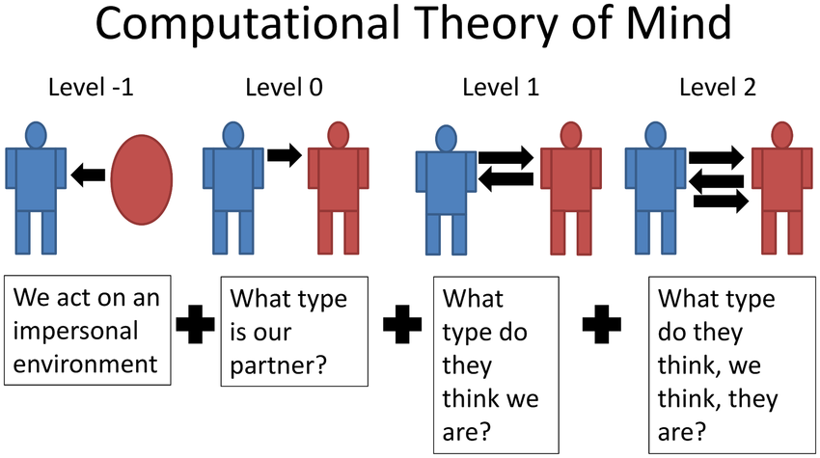

Figure 1: Illustration of level-k thinking

Likewise, a level-2 player will choose actions that are the best response given the belief that all opponents are exactly one level below and so on. Multiple studies have tried to fit experimental choices using level-k theory (Crawford & Irriberri, 2007; Östling et al., 2011; Arad and Rubinstein, 2012) as well as attempt to estimate the level-k distribution of strategic sophistication in participants (Stahl & Wilson, 1995; Costa-Gomes & Crawford, 2006). These estimates suffer however from a lack of consistency according to Georganas et al. (2015) which posit that participants actions reflect their beliefs about the level of strategic sophistication of their opponent rather than their own. Provided that distinct game types elicit distinct beliefs about opponent sophistication, the inferred levels will vary from one experiment to the other (Agranov et al., 2012). Cognitive Hierarchy models (Camerer et al., 2004) are very similar to level-k models except that players are supposed to reason based on the assumption that their opponents are drawn from a distribution over lower level-k reasoning abilities, rather than come uniformly from the immediately inferior level.

Generalization to repeated game settings

While these models have helped fit experimental data better, they suffer from the fact that they have mostly been used in one-shot rather than repeated games, and as such remain little tested in our framework of interest. As we discussed previously, repeated games are a better model for social interaction and the need to model the opponent. The fact that the games are repeated changes fundamentally some of the foundational results of game theory and introduces the possibility of learning agents able to refine their behaviour through time.

For instance, the concept of Nash equilibrium needs to be adapted to repeated games, and most research uses a refinement of the original concept called Subgame Perfect Nash Equilibria: these are strategies that represent a Nash Equilibrium of every subgame of the original game. An important theoretical result in game theory, known as the Folk Theorem, posits that if a player is patient enough about rewards (a low discount rate), then repeated interactions allow many Subgame Perfect Nash Equilibria (Friedman, 1971). In particular, if the stage game has multiple Nash equilibria, then the repeated game may have multiple SPEs, which introduces the possibility of strategies involving punishment as well as reward that help support deviations from Nash equilibria in early rounds.

Moreover, multiple experimental results show that human participants do not initially play according to Nash Equilibrium. However, with repetition, convergence towards the Nash Equilibrium choice occurs (See Camerer, 2003 for a review). Also, when comparing several algorithms including Nash Equilibrium oriented ones, on several games in matrix form, Zadawski (2005) concludes that they are inferior to other approaches that use the concept of best response to other players.

**Theory of learning in games**

The results we saw in the context of repeated games render the normative framework of game theory inadequate to deal with the complexity of repeated interactions. Hence the need for models that offer a theoretical basis for this improved behaviour through time. In the following sections, we will present two classes of learning models in games, those that are based on the concept of reinforcement learning, and those that can be classified as using information about the opponent to inform play.

Reinforcement learning

The key idea behind reinforcement learning models (Sutton & Barto, 1998) is that players have a higher probability of repeating actions that yielded a positive reward in the past (positive reinforcement) and likewise, are less likely to choose actions that did not historically lead to a reward or were associated with a penalty (negative reinforcement). The RL framework is based in Markov Decision Processes (MDP), where the world can be in one of multiple states, and the agent’s actions will lead to state transitions that determine future rewards and new word states. The aim is to find a function that takes as input a state of the environment and outputs an action to be taken in that state such as long-term cumulative reward is maximised.

Multiple RL algorithms have been devised. Model-Free RL aims to learn the values of the states without knowing the full transition process of the MDP. A particular type of model-free RL algorithm uses the difference between the expected and actual reward to update and ultimately learn these values (Sutton & Barto, 1998). Recent results in neuroeconomics suggest that the brain may use model-free RL for learning tasks since experiments in primates show that activity in dopaminergic neurons is correlated with the reward prediction error (Schultz et al, 1997). This correlation was shown to in fact be causal in rodents using optogenetic activation of these neurons (Kim et al., 2012). This approach is better suited to modelling repeated game as it involves the notion of learning from past actions and optimising cumulative rewards over time. In fact, Erev & Roth (1998) demonstrate through experimental data on repeated two player games that a single parameter RL model is better than the assumption of convergence towards Nash Equilibrium in fitting empirical observations.

Another RL approach, known as model-based RL, learns the parameters of the MDP that specify the environment before finding an optimal policy. One example of this type of algorithms is Dyna-Q (Sutton and Barto, 1998). Once the model of the environment is known, it is easy to compute the values of the states and actions associated with them using either dynamic programming as in model-free RL or by expanding a look-ahead decision tree. Though the latter is computationally challenging as the number of branches in the tree grows exponentially with its height, which necessitates pruning, something experimental evidence confirms humans do especially through elimination of branches leading to large losses (Huys et al., 2012).

Although the various RL algorithms have successfully modelled behavioural traits of human play in repeated games, many challenges remain: Human players are prone to alternate rather than repeat actions that led to positively surprising rewards in both Financial markets and n-bandit tasks (Erev, 2012). Other studies find that heuristics such as ‘win-stay, lose-shift’ do a better job of modelling human behavior in the Iowa gambling task than RL algorithms (Worth et al., 2013).

Opponent modelling as a learning paradigm:

Opponent modelling is an umbrella term designating any strategy that uses information about the opponent, whether an abstracted description or observation of actual play, to improve the capability of the player in the game, exploit weaknesses of the opponent or maximise long term reward (Bakkes et al., 2009).

This process seems to be prevalent and perhaps automatic in humans: Multiple studies have shown that people take into account information about the opponent when playing cooperative games by changing the amount they risk based on rapid evaluations of the opponent, even in the absence of history of play (De Bruine, 2002; Hancock & DeBruine, 2003).

As such, opponent models may have evolved to allow players to sometimes have a higher reward from playing a game even though the game-theoretic solution is known, through exploiting non optimal play from the opponent. As an example, while the game of Rock, Paper, Scissors admits only one Nash equilibrium (a mixed strategy of randomly selecting actions with equal probability) against which the best one can hope for is a cumulative draw, it is possible through learning about the opponent strategy to have a positive long term reward through exploiting deviations from the equilibrium path by the opponent. For instance, if we observe that an opponent plays Rock with a probability higher than 1/3, we should choose paper more often than one third of the time, which would lead to a long term positive reward.

This simple idea was formalised by Brown (1951) in an algorithm called “Fictitious Play”. It is based on players continually updating beliefs about the frequency at which opponents choose actions, through observing past interactions, and choosing best responses. While this approach weighs all past actions equally, an alternative used by Cheung & Friedman (1997) is to give a higher weight to more recent observations, which successfully models heterogeneity of players and fits experimental data better.

This strategy however assumes players don’t reason about their own past actions, and how these might have affected the opponent choices. We also saw that Reinforcement learning strategies do not explicitly reason about the opponent actions, and don’t include any information about foregone payoffs from choosing a different strategy. As such, Camerer and Ho (1999) suggested a framework that generalizes both methods: The Experience Weighted Attraction (EWA) model. This model posits that players differ in the importance they give to foregone payoffs, parametrised through a variable *d* that varies between 0 and 1. When *d* = 0, no importance is given to foregone payoffs and this corresponds to a reinforcement learning approach, while a *d* = 1 maps to fictitious play. Camerer & Ho (1999) find that EWA improves accuracy compared to its special cases (RL and FP) in 35 different games. It also has better out of sample predictive power and can be improved through reducing the number of parameters required to be fit through an improved algorithm: self-tuned EWA.

Uncovering the distribution of opponent actions is just one-way players can model their opponents. Indeed, the opponent action frequencies might not be distinct from a potential Nash equilibrium, but the pattern can be highly regular and as such models based on pattern recognition and sequence prediction can exploit temporal correlations in the opponent strategy. For instance, in “Rock, Paper, Scissors”, an opponent strategy can be highly exploitable even though the frequency of actions is the same as in a Nash equilibrium. If the choices are not random (for instance players follow the exact sequence: Rock, Paper then scissors) then fictitious play would not pick up the deterministic nature of the opponent strategy even though it is 100% exploitable by simple following the sequence of best responses. One way to extend fictitious play is to focus on the frequency of short-term sequences rather than that of individual actions. One could build a probability distribution of all sequences of length n over time and best respond to that (Spiliopoulos, 2013): Using a repeated 2x2 game with a unique MSNE, this study shows that a learning model that aims to detect patterns of length 2 outperforms EWA in both fitting the experimental data and in out of sample prediction of participants’ behaviour.

The common denominator between all the learning models we presented so far, is that they focus on action choices: whether fictitious play or reinforcement learning, the underlying principles in all those models is that actions that have proved positive are chosen with a higher frequency. By contrast, we can think of other types of models that think of players’ behavior in terms of *choices amongst rules*, with a positive reinforcement over-time for rules that have done well, and a negative reinforcement for those that led to poor performance.

To be more precise, a behavioural rule is any function that outputs a probability distribution over actions when given information about the game and history of play (Haruvy & Stahl, 2012). For instance, strategies such as “Trigger” and “Tit-for-tat” are behaviour rules. Some studies show that rules-based models fit data equally well, compared to action-based models. For instance, Erev & Barron (2005) showed while exploring learning in simple tasks that cognitive constructs such as loss aversion and hill climbing which are closer to rule-based strategies do as well as a model set up to learn between actions. Stahl (2000, 2003) both showed that rule-based models had a better fit and provided novel insights in repeated normal form games when these were played sequentially with a similar horizon. More importantly, some studies show that human players learn to reason about the games rather than merely learn to choose particular actions. Ho et al. (1998) conducted a study of p-beauty contests where players played two variants of the game in two different runs. They found that in the final run, participants learned to play the equilibrium choice faster, although no difference between experienced and unexperienced players is found in the first run, indicating that players learned strategic rules and transferred that learning rather than engaging in immediate transfer of learned actions.

The findings of Ho et al. (1998) are important because they indicate a way forward in our quest to determine which learning models describe best the cognitive processes involved in repeated game play. Indeed, these models make different predictions in situations where humans engage in similar tasks sequentially, and whether learning gets transferred across games. In a later section, we will explore the literature about learning transfer. But before that, having seen opponent modelling as a learning paradigm in humans, in this section, we will now focus on how the AI community has used opponent modelling approaches to build better algorithms.

**Opponent modelling approaches in AI research:**

Contemporary AI has seen the emergence of multi-agent systems, where agents are expected to interact seamlessly with others. In order to achieve that, it is important for the agents to be able to take into consideration the goals, beliefs and actual behaviour of the other agents in the system. One way to achieve that is for them to learn a model of the other agents, i.e. a mapping that takes as input the observed interaction history and outputs a prediction about future actions, or a feature of the other agents that might aid future interaction. This process is known in the AI literature as agent modelling or opponent modelling.

Modelling other agents has seen a flurry of research interest in the AI community, driven by ever increasing applications that require a reliable model of other agents. For instance, driverless cars must build a model of other vehicles to navigate in the real world ( Buehler et al., 2009); Smart tutoring systems need a model of the human students to uncover misconceptions in learning (McCalla et al., 2000) and automated chatbots used in facilitating the customer experience need to learn the intentions and goals of the user (Grosz and Sidner, 1986).

Opponent modelling research traces its roots as far back as the emergence of game theory in the early 1950s, where in the context of computing equilibria, some methods built explicit opponent models such as fictitious play (Brown, 1951) where players build a model of the frequency distribution of opponent actions. Kalai and Lehrer (1993) proposed another model called rational learning in which players update Bayesian beliefs over strategies the opponent might be using. Other researchers proposed models built on recursive reasoning (Gmytrasiewicz et al., 1991).

Since this early research, many more modelling techniques have been developed to serve the needs of the specific communities in which they were used, such as commercial video games, automated negotiation and multiagent learning. In the following section, we will aim to give an overview of the most salient opponent modelling methods used so far. We will distinguish between models based on policy learning, type-based reasoning, classification and recursive reasoning. Finally, we will review the latest development of opponent modelling techniques integrating the recent advances in deep learning.

Policy learning

These methods aim to build models that provide an explicit prediction of future opponent actions through uncovering patterns in the agent’s decision making process. They are equivalent to reverse-engineering a hypothetical policy the agent might be following.

One way of doing that is through modelling action frequencies. The most obvious example, which we previously mentioned, is fictitious play (Brown, 1951) in which the model is simply a probability distribution over the opponent’s action space, and the probabilities are estimated using maximum likelihood methods over past observed actions. However, an issue with fictitious play applied naively is that it struggles with complex dependencies of the agent actions on the history of the interaction. To overcome this difficulty, later models chose to condition the distribution over the action space on past actions of both the agent and the opponent. Banerjee and Sen (2007) built a model of the opponent that learns the action frequencies conditioned on the agent’s own past actions. Davidson and Hirsh (1998) in contrast built a model that learns based on the opponent’s own previous actions. Others condition on more complex interaction history such as the cumulative *n* most recent actions (Powers and Shoham, 2005).

One notable weakness of the above models is that they have no inherent mechanism to generalise the knowledge accumulated in a specific environment to new environments even though the latter may be very similar. To overcome this issue, Case Based Reasoning has been proposed as a mechanism to generalise knowledge from past experiences (Hammond, 1986; Veloso, 1994). This method keeps in memory a set of “cases” as well as observed actions on each case. To generalise knowledge to previously unseen situations, a similarity function is computed to output the historical cases that most resemble the current environment state, and the action predicted depends on the ones previously observed in these similar cases. In a similar vein, more complex case-based reasoning methods were developed to take into account the similarity as well as the recency of the observed cases (Hsieh and Sun, 2008; Albrecht and Ramamoorthy 2013).

While the methods described above have the advantage of being non-specific to a domain, this generality comes with a high computational cost due to the combinatorial explosion of the state-action space data points needed (many observations to store, and each observation may have many possible values). This issue has led to the use of Deterministic Finite Automata (DFAs) as a way to model an agent’s decision making (Carmel and Markovitch, 1998). These are models that learn if the opponent’s actions can be compactly modelled by a simple graphical model, checking as observations come through whether they are in line with the existing graph, and if not, modifying the graph by adding new nodes and edges. These methods search for the most compact DFA that is consistent with observations. Other researchers used different representations to model behaviour such as decision trees (Barrett et al., 2013).

Other methods that can fall under the policy learning classification aim to learn the opponent’s preferences that might be expressed through an implicit utility function. This helps in predicting the opponent next action by finding the move that would maximise the modelled utility function of the opponent. Carmel and Markovitch use this method to model opponent in the game of checkers (1996, 1993) by considering a utility function that is linear in features of the game state, using the coefficients of the features in the combination as learning parameters.

Learning the opponent type (stereotyping)

The methods described above to learn the opponent policy suffer from a high computational cost and need many interactions and vast amount of data in order to learn the policy the opponent might be following. As such, they may not be a good basis for modelling human behaviour due to cognitive constraints, nor to situations where the agent is not given the opportunity to interact extensively with the opponent and where fast learning and adaptation might be more important. To use an intuition from case-based reasoning, it would be interesting if an agent can use prior interaction to retrieve from memory a ready-made model of the opponent. In essence, the agent can assume (have a prior belief) that the opponent belongs to a set of pre-defined “types” and act according to the optimal actions for each type. After each observation, the agent can update its belief (using Bayes’ rule) based on the likelihood of observing the previous action from the opponent given the type they belong to. These methods, known as type-based reasoning, were explored extensively in both game theory and AI research because they offer fast learning assuming the opponent’s type belongs to or is very similar to the set of types in the prior. In game theory, a result by Kalai and Lehrer (1993) shows that in games where players update a prior belief about the opponent’s type, their predictions about how the play will develop will be accurate models of future interaction and this process facilitates convergence to Nash equilibrium (under some assumptions about player’s belief being “continuous”, in the sense that all events with true positive probability is accounted for in the belief of the players with a positive probability).

In AI research, this type of opponent modelling was used in problems where multiple agents interact without prior knowledge of the other agents behaviour (Stone et al., 2010). Albrecht et al. (2016) proposed an algorithm that maintains a set of user-defined types used as prior beliefs that are updated using the agent’s observed actions. These beliefs are subsequently used in a planning procedure to calculate each action’s expected payoff and choose the optimal one (recursively using a combination of Bayesian Nash equilibrium and Bellman optimality equations). As in case-based reasoning, the type of the opponent does not necessarily need to be in the pre-defined set of types. Barrett et al. (2013) show that using types modelled as decision trees, unseen types can be learned through using similarity measures with types from previous interactions and transfer learning. Takahashi et al. (2002) uses multiple “modules” in a reinforcement learning method where each of these corresponds to a particular type, supplemented by a gating signal that dynamically determines how similar is the current opponent to the existing modules.

While all methods above are inherently Bayesian, since they update prior belief given current actions, other methods use machine learning approaches to learn the type given the history of observed actions, or the mixture of types most closely matching the observed behavior. For instance, He et al. (2016) trained a neural network to serve as a “gate” using as input the Q-values of multiple “expert” modules each corresponding to an agent type. We will review these methods in detail in the last part of this section.

Conceptual classification of opponent features

Rather than trying to predict the opponent’s next action directly, as is the case in policy learning and type-based learning, other methods might try to learn specific features about the opponent’s play style to inform future strategy. These may be abstract concepts the agent uses to label an opponent, such as “aggressive”, “trustworthy” or “risk averse” that are based on past interaction.

There is a rich literature of classification methods such as these in the complex game domain. Weber and Mateas (2009) train models by using replay data from expert human players in the game Starcraft to predict a player’s strategy. Each replay is labelled using one of 6 strategies and ML algorithms are then tested on the data with the outcome that the learned models can predict the player’s strategy. Shadd et al. (2007) use classifiers in the game of Spring to predict the opponent style of play (on a scale of aggressiveness) and give more weight in their classifier to more recent observations to account for potential dynamic opponents that may change their style. In the game of robot soccer, Riley and Veloso (2000) build a classifier that uses a grid over the football playing field to count the occurrence of specific game events in each cell as an indicator of the opponent’s type.

The above has also been extended to human-like notions such as trustworthiness and trust. Abdul-Rahman and Hailes (2000) classify opponents on their trustworthiness based on past observations as well as reported indirect experiences from other agents.

Reasoning recursively about the opponent

Not unlike the use of theory of mind in cognitive sciences to explain human’s ability to reason about other’s belief and goals recursively, the research community in AI has investigated recursive reasoning as a way to explicitly represent the reasoning process of other agents as nested beliefs ( I think that you think that I think…)

To avoid issues with infinite regress, these methods choose a predetermined fixed level of depth at which the recursion is stopped. At that level, the actions are assigned some trivial probability distribution (uniform for instance) and these are fed into the above recursion level which in turn is fed to the next level and so on until the agent can make an actual choice that is a best response. Carmel and Markovitch (1996) use a similar method as outlined here to search game trees when players engage in games with sequential actions. Gmytrasiewicz and Durfee (1995) also implement a similar recursive model in cases where the agents also have uncertainty about the reward function of the opponent as well as their level of recursive reasoning.

The above method raises important questions, such as how to choose the optimal depth of recursion when dealing with humans and other agents. There is evidence from human economic game play that humans are on average level 1.5 thinkers, meaning that one or two levels of recursive reasoning are sufficient (Camerer et al., 2004). When analysing artificial agents playing amongst themselves, De Weerd et al. (2017) find that when reasoning levels rise above 2, only marginal benefits are achieved when testing agents in games such as repeated RPS and automated negotiation.

Recent Deep learning approaches to model opponents

In recent years, deep neural networks have had multiple successes in different domains such as computer vision (LeCun et al., 2015) and natural language processing (Schmidhuber, 2015). One of the key advantages of deep neural networks is that they can uncover compact representations in big, complex and high-dimensional data. When using these tools with reinforcement learning, Deep Reinforcement Learning (DRL) algorithms are trained to approximate an optimal policy or an optimal value function (Sutton & Barto, 1998), which allows RL to scale to problems with very high state and action space dimensions. Deep reinforcement learning is considered an important component in building advanced AI systems especially since it has been integrated with other techniques such as multi-agent learning to give the foundations of a multi-agent deep reinforcement learning (Nguyen et al, 2018).

In the context of opponent modelling, an early approach of using deep neural networks to model opponents is that of Deep Reinforcement Opponent Network (DRON; He et al., 2016). This model relies on two modules: a network to evaluate the Q-values, and another to learn a model of the opponent policy. Q-values in the context of reinforcement learning are state action values: The represent the cumulative expected reward of taking a specific action in that state. For Q-value estimation, the model combines the predictions of multiple expert networks, such as each of these experts captures one type of the opponent’s strategies.

While DRON relies on hand-picked features to build the opponent network, Deep Policy Inference Q-Network (Hong et al, 2018) uses auxiliary tasks as additional goals to directly infer the opponent’s policy features from raw observations. This is done through embedding an auxiliary loss in the loss function that depends on how far the inferred opponent policy is from the observed truth. The key advantage is that this approach can work for both inferring opponent’s and collaborator’s policies in multiple settings.

Both approaches above rely on learning the opponent policy through observing past actions, by contrast, Self-Other modelling (Railaneau et al., 2018) uses the agent’s own policy as a way to simulate the opponent’s, in a strategy reminiscent of cognitive simulation theory in the study of theory of mind in humans (Goldman, 1992). The Self-Other modelling architecture uses separate networks, the first for continuously evaluating the agent’s own policy, and the other for learning the opponent’s goal in the task, while relying on the assumption that these two networks would share the same architecture with similar initial parameters but might converge to different values. Unlike the approaches outlined above, the goal is not to learn a probability distribution over the opponent actions, rather it is to infer the goal of the opponent, which is a hidden state that is assigned to the opponent from a set that is shared with the artificial agent. These can be abstract goals the depend on the game environment and not necessarily correspond to learning the value function

Other approaches have inherited game theoretic concepts to build agents. For instance, the Minimax Multiagent Deep Deterministic Policy Gradients (Li, 2019) gets its inspiration from the game theoretic concept of minimax which tries to minimize the worst-case scenario, i.e. a scenario where the opponent actions result in a maximum loss (Von Neumann, 1945). This approach updates the agent’s policy by assuming the opponent will necessarily adopt an adversarial approach which gives a minimax learning objective.

None of the approaches so far account for the possibility that the opponents are also learning while trying to infer their policies. This is exactly the novelty in Learning with Opponent-Learning Awareness (Foerster et al., 2018). The algorithm aims to maximise the expected reward following a one-step policy update performed by the opponent. As such, LOLA is a method in which each agent shapes the anticipated learning of the other agents in the environment. When two LOLA agents play the iterated prisoner’s dilemma game, there is emergence of strategies such as tit for tat that encourage cooperation. Also, it is shown that this method performs better than a naïve learner in IPD and is immune to exploitation by higher order methods that use gradient descent.

Other models yet get their inspiration from human theory if mind ability and the recursive reasoning process it entails. Theory of mind Network (Rabinowitz et al., 2018) is an architecture composed of three modules: 1. A character network that aims to learn about the opponent from historical interaction. 2. A mental state network that use that character output as well as the recent trajectory to simulate the opponent hidden dispositions and 3. A prediction network that takes its input from both modules and aims to predict future behavior. The study shows that this network can learn to learn about the agents it encounters based on observation from behavior alone. It is akin to learning to acquire a strong and rich prior model for agent’s behavior. The study shows that it learns to model random, as well as algorithmic and DRL agents from a diverse population of agents and even passes classic human theory of mind tests such as the Sally-Anne false belief test (Wimmer & Perner, 1983)

Section Conclusion

Given the large variety of learning models we presented above, it can be overwhelming to decide which models best fit human behavior and which are most suited to building intelligent agents capable of efficient interaction in repeated games. In the following section, we will use the ability of these approaches to generalise from one game to the other as a benchmark for their ability to emulate this human skill. We will thus explore learning transfer literature in detail and contrast the empirical evidence for it in repeated games against predictions of the learning theories we highlighted above.

**Human Learning Transfer in Sequential Games**

Being able to successfully transfer previously acquired knowledge to a new domain is one of the hallmarks of human intelligence (Taylor et al., 2008) and is likely to be a key component towards building a general artificial intelligence. Humans are naturally endowed with the ability to extract relevant features from a situation, identify the presence of these features in a novel setting and use previously acquired knowledge to adapt to previously unseen challenges using acquired knowledge. More formally, Perkins (1992) defines transfer of learning as the application of skills, knowledge, and/or attitudes that were learned in one situation to another learning situation.

First, looking at findings in the classic psychology literature, there is little evidence for positive learning transfer across domains in a general sense (Solomon & Perkins, 1989). Rather, transfer is seen as dependent on a set of specific conditions about the tasks and the learner which are not necessarily met in everyday life let alone laboratory experiments, such as high similarity between tasks and the ability to practice a skill to near automaticity (think of driving similar cars after having learned to drive).

In the context of repeated games in laboratory experiments, there are seemingly inconsistent results when scouring the literature: Ho et al. (1998) test for transfer in two similar games that rely on iterated dominance principles and show the absence of transfer from the initial to the final game. Likewise, in a run of experiments, Cooper & Kagel (2003, 2005, 2008) show that there is no transfer when players engage in two signalling games successively. There is however evidence for transfer when the experimental interventions encourage participants to reflect on the games structure. On the other hand, other studies have shown that learning is transferred between games played sequentially (Stahl, 2000; Rankin et al., 2000; Rick and Weber, 2010).

To make sense of these discrepancies, the notion of similarity needs to be defined more thoroughly. For instance, Camerer & Knez (2000) distinguish between games that are similar in a purely descriptive way, meaning similar choice labels, identity of players, format and number of action choices; and games that are similar in a strategic sense, meaning similar payoffs from combination of actions, identical equilibrium properties or significant social characteristics of payoffs such as possibility of punishment, need for fairness and cooperative vs competitive settings. In this particular experimental paradigm, participants played two games sequentially against the same opponent for a limited number of rounds. In the first condition, the two games were both descriptively and structurally similar, while in another condition, the two games were only strategically similar. Researchers measured transfer by the likelihood of cooperating in the latter game given that the players chose the efficient outcome in the former. They find that transfer of learning occurs more readily in the presence of both descriptive and strategic similarity (increasing the propensity to cooperate from 15-30% to 70%). If the games were only strategically similar, then the transfer was much weaker.

In another experiment, Juvina (2014) explored transfer of learning between games played sequentially (prisoners dilemma followed by a game of chicken) and whether deep or superficial equivalence (mapping out to concepts we saw above of superficial and strategic similarity) was driving this learning spill-over. Participants engaged in the games sequentially with a counterbalanced treatment (some playing PD first, the others playing the chicken game first). In a clever experimental design, the order in which the games were played allowed them to infer which type of similarity was driving the transfer. Interestingly, their results point to a different conclusion from the previous study of Camerer & Knez (2000). In this case, their experimental results indicate that most transfer was in fact driven by strategic similarity, while superficial similarity on its own either helped or hampered optimal play depending on its priming effect on players. These results are confirmed by a later study by Mengel & Sciubba (2014) where they find that the propensity of participants reaching Nash equilibrium or coordinating actions in a later game was higher in the presence of strategic similarity.

From the above, we can see that the similarity between games (superficial or strategic) is one factor that can affect transfer, but it may not be the only one. As well as the variability in experimental conditions, the type of learning that occurs within tasks is likely to be a contributing factor in whether transfer occurs or not.

It is important to mention the two types of learning that the psychology literature has identified, based on the way the learning occurs, the type of knowledge produced by it and the ability of the learner to articulate and transfer it. The first type of learning is “implicit” and represents a process that yields knowledge that is hard to articulate nor is it cognitively available (Holyoak and Spellman, 1993). This type of learning mostly relies on heuristics or associative processes, bypasses cognition and therefore is unable to produce conceptual representations of what it being learned (Mandler, 2004). As such, this type of learning cannot be manipulated cognitively or easily transferred to a new task (Holyoak and Spellman, 1993). The other type of learning is, by contrast, called “explicit” and represents a process through which “knowledge consists of cognitive representation of concepts and rules, as well as the relationship between them. It involves the evaluation of explicit hypotheses and results in better problem-solving skills” (Mandler, 2004). Since it depends less on the context in which it occurs, this type of learning is easily transferable to new tasks and dissimilar settings.

When the type of learning is implicit, then descriptive similarity is important as it allows players to map previous choices to new possibilities easily. However, when there is only strategic similarity, this type of learning cannot easily be transferred, which may explain the initial absence of transfer in Ho et al. (1998) and Cooper & Kagel (2003, 2005, 2008). What is notable is when experimenters intervened to make participants think about the game structure, evidence for transfer emerged. For instance, in the latter papers, only when subjects were given meaningful context for the games or allowed to discuss the games in teams did the transfer occur.

In Cooper & Kagel (2005), relying on a fictitious play learning model that has worked well in tracking play from previous signalling games was not sufficient to account for the change in strategic behavior of players The researchers fitted a modified fictitious play model to the data by including sophisticated learners who are able to take into account how the opponent makes decisions and anticipate changes in their behavior when payoffs changed. They find a statistically significant fraction of these sophisticated learners, and that the proportion of these learners increases over time.

This view about the importance of the type of learning in transfer is supported by other experiments that used interventions from psychology to impede superficial learning and encourage explicit learning: The psychology literature is familiar with the counterintuitive finding that people engage in deep and significant learning when given minimal or delayed feedback (Salmoni et al., 1984; Lurie and Swaminathan, 2009). The same intervention was used in the context of learning within and between games: Weber (2003) made players engage in 10 rounds of a dominance solvable game without feedback and found strong convergence towards equilibrium. However, the latter study did not deal with learning transfer. This was done by Rick & Weber (2008) who conducted three experiments using dominance solvable games all of which showed that learning transfer is present in the absence of feedback between rounds of games, and that when feedback is given then the players learn a strategy which is akin to superficial learning that fails to transfer . They interpret this as evidence that more meaningful learning occurs when feedback is hidden, and explain it by suggesting that feedback may impair significant (explicit) learning by diminishing the incentives and ability of players to think deeply about the game played (Anzai & Simon 1979)

The above literature review suggests that there are two components that contribute to learning transfer: the degree to which the games are descriptively and strategically similar, and the type of learning that occurs. The seemingly contradictory results on learning transfer can be explained by the superimposition of these two effects: For instance, if the learning was superficial (based on action choices), and there was an easy mapping between games on these action choices due to descriptive similarity, then participants would continue to play the actions that were reinforced initially regardless of whether they have the same strategic benefit. For instance, a Fictitious Play learner treats their opponent as a fixed distribution over action choices. In the presence of a descriptively similar but strategically dissimilar game, they do not anticipate a change in the opponent behavior, and will only begin to play optimally after multiple instances in which the old actions are no longer as rewarding due to new opponent choices, therefore they first need to unlearn old distributions. In contrast, if players really are learning something deeper and more fundamental about the game, like the fact that the opponent strategy can be modelled using iterative reasoning, or that the opponent has a salient social feature (need for fairness, reciprocity…) then these can be easily transferred to strategically dissimilar games.

We can easily see the parallels between the psychological construct of implicit learning and some action-based learnings models, such as model-free reinforcement learning. By contrast, the explicit learning is more comparable to rule-based strategies. Some studies even attempt to intervene to encourage one learning vs the other and look at the consequences on transfer. (Rick and weber,2008).

**Learning Transfer in AI research**

There is a large literature in machine learning on how to transfer learning between datasets for purposes of classification, regression and clustering (See Pan & Yang 2009 for a review). In this section, we will focus on machine learning approaches to transfer knowledge in tasks more akin to reinforcement learning. Our artificial agents encounter various environments in which they need to act optimally, and as thus, the RL framework is more appropriate.

We can articulate at least three usual measures through which the application of transfer might improve learning. First, there is the early performance of the agent in the new task prior to any new intra-task learning, meaning the learning is directly attributable to the knowledge transferred from the source task. Second is the speed of learning of the new task provided knowledge is transferred from a prior source task, compared to the amount of time it takes to learn the new task from scratch. Finally, the final performance score of the learner using transfer compared to someone who hasn’t trained on a source task (Torrey & Shavlik, 2010).

Many algorithms presented above such as Reinforcement learning have been shown to succeed in many areas when a single agent is performing a single task, assuming the agent is given sufficient time and enough trials to learn. However, in the presence of multiple tasks, the algorithms need to learn a new model entirely. To improve this inefficient practice, transfer learning algorithms use the knowledge accumulated while learning the original (source) task to improve the performance in a related, but new (goal) task (Taylor and Stone, 2009). This is very useful in the game domain or in repeated interactions, as previous information about the game or the opponent can be used to quickly learn how to best behave against the same opponent in a new game environment, and as such build a new acting policy quickly. This can be seen in performance on new tasks where both initial performance and speed of learning are higher than what is warranted without transfer (see figure 2)



Figure 2: Performance on tasks with and without transfer from prior training

For all RL algorithms, Q-values get initialised at a random or zero solution, and through interacting with the environment, the agent converges towards an optimal solution. One way of transferring learning from a previous task is to start the new task by initialising parameters using good target-task solutions. For instance, Taylor et al. (2005) use optimal values for the source task value function as initial parameters for the goal task value function. For such an approach to work, a mapping of actions and features between the source and goal tasks is needed, and the researchers provide this mapping manually based on domain knowledge. In the simpler case where there is no function approximation, but the tasks can be learned using a tabular model, Tanaka & Yamamura (2003) simply initialize the goal task as the average of tables from previous source tasks. Wilson et al. (2005) perform transfer using a model-based Bayesian RL algorithm by using the distribution of source task MDPs as a prior for the goal tsk MDP. Likewise, in genetic algorithms performing policy search, the initial population of policies in the new task is given by successful policies in the training tasks (Taylor at al., 2005).

Another way of transferring previously acquired knowledge is to occasionally make use of the source task policy in the new task, rather than random exploration from scratch. As such, actions that are based on source task policy may lead the agent to explore more efficiently and direct them towards promising areas of the environment. Madden & Howley (2004) for instance use source task policies on exploration steps only. Fernandez and Veloso (2006) provide the agent with the choice between three options: Random exploitation, exploitation of past policies from source tasks, and exploitation of currently learned policies in the goal task. They control the choice through adding a probabilistic parameter that determines the likelihood of each choice.

When the source tasks can be viewed as subtasks of the goal task, the framework of Hierarchical RL is used, whereby solutions to the source tasks can be put together and considered as building blocks of the solution to the goal task. Specifically, when the new task to be learned can be considered a temporal composition of subtasks the agent already trained on, then solving the goal task can be done directly (Sigh, 1992). Another approach is to use the concept of options in RL. An option is a set of actions that happen over time, that bring the agent from an initial to a final condition, following an internal policy over low level actions. For instance, in robot soccer, the ability of passing the ball can be viewed as an option, with an initial state, the lower level actions of running toward the ball, kicking the ball then running again, and the final state. Croonenborghs et al. (2007) use the entirety of the source task policy as an option in the goal task. Asadi & Huber (2007) search for frequently visited states in the source task and use them as ending conditions for options used in the goal task.

Other algorithms take an entirely different approach to transferring knowledge by incorporating it as an inherent part of the RL process. One way is to make the value functions depend on observation by expert agents (Price and Boutilier, 1999). The value function update equations are augmented by a term denoting the expert’s experience, weighted by the confidence the agent has in the expert. Sharma et al. (2007) store cases from both the source and target tasks in a library, provided their distance to their nearest neighbour is above a threshold. the Q-functions are then calculated using Gaussian kernels overs the cases stored in the library. This algorithm is an instance of case-based RL. Another instance by Taylor et al. (2005) who use source task cases when sufficient examples of target tasks exist and use exclusively target task cases when they are sufficient to make a decision.

Having seen different ways in which researchers account for learning transfer in both human and artificial intelligence, we can summarise our findings as follows: Research in learning transfer in AI is still at its infancy, and algorithms that truly generalize to new situations without expert knowledge is still an area of open research. By contrast, psychologists have studied learning transfer in the context of repeated games extensively. The main distinction from the repeated games literature is between action based and rule-based approaches for learning to anticipate the opponent movements. Action based approaches focus on uncovering the distribution of actions, and as such should only lead to generalization in similar games where mappings between past and current actions is easy. By contrast, rule based strategies allow a more fundamental learning of the opponent model, and should lead to easier generalization to both strategically similar and dissimilar games.

We believe that uncovering some fundamental principle of how humans achieve this will deepen our mechanistic understanding of learning generalization broadly, and transfer in strategic sequential interactions in particular. This is why we will aim to uncover which approach is most likely to explain human behavior in our repeated sequential online experiments.

## This Study

The underlying premise of this research is that the ability of players to learn a model of their opponent that goes beyond solely learning the frequency of opponent play is the key behind the ability to generalise knowledge about the opponent playing rules, which would manifest as a learning transfer between games.

Most studies on learning within and across games tend to use dyads of human participants competing against each other. This experimental procedure significantly diminishes the degree of experimental control available to the researchers since humans are capable of learning from the opponent strategy and will continually adapt their own strategies to outsmart the opponent. This makes it difficult to disentangle learning effects within and across games from available data, and therefore we will focus here on the use of human participants playing against a computer opponent that uses a controlled, predetermined strategy to choose actions.

We saw in the literature that some studies did use computer opponents with fixed strategies. These studies focused on testing human player’s abilities to detect and best respond to the computer’s strategy. However, most of the strategies did not take into account the human player’s history of play or strategy. They were mostly based on pre-determined action-based strategies such as fictitious play or reinforcement learning. Specifically, none of the studies we reviewed used an agent capable of reasoning strategies, such as a level-k or cognitive hierarchy type of agent.

In this study, we therefore propose to contribute to the literature on learning within games and learning transfer through making human participants face computer opponents that apply reasoning-based strategies that are consistent with level-k thinking. We programmed two computer opponents, Alpha and Omega, that keep the same strategy throughout experiment, but are different in that Alpha chooses actions based on a level-1 thinking approach, and Omega chooses its actions using a level-2 strategy. All participants face both opponents, one after the other and the interaction with each opponent is repeated once for each of the games. Which opponent the participants faced first was counterbalanced. In a 2012 study, Haruvy & Stahl show that these level-k rules can be learned by humans and are generalised and transferred to dissimilar games.

In total, players will engage in 3 games, the first two are both descriptively and strategically similar, while the last one only has strategic similarity with the first 2. We hope to explore various interesting questions by using the above experimental paradigm, and more precisely we will test the following hypotheses:

**Between Game Transfer of learning**

We are primarily interested in the presence of learning transfer across games. The research hypothesis is that human players transfer what they have learned about the opponent across similar and to a lesser extent dissimilar games. We will mostly focus on the likelihood of choosing a winning action at the inception of the goal task (latter games), having had the opportunity to learn about the opponent in an initial source task (initial game). WE predict that participants will score higher on early stages of the later games, than they did in early stage of RPS, since they will transfer learning from prior interactions to later tasks. As a robustness check, we will vary the number of early rounds in goal tasks across which the transfer is measured.

**Effect of agent’s strategy on transfer: rule-based vs action-based explanations**

Participants will face two computer agents; both have the same overall strategy based on level-k1 and level-2 reasoning respectively. The level-2 agent is considered more sophisticated than a level-1 agent, and as such, it should be harder for participants to learn its strategy and transfer it. However, because the games chosen all have three actions, the circular dominance amongst actions translates into very simple heuristics that players can learn against a level-2 agent ( Play whatever the agent chose last round), and if indeed players are relying on such heuristics, then they should do better against such an agent. As such, we will compare the overall average scores against each agent and measure the degree of within-game learning and between-game transfer.

**Effect of similarity between games on transfer of learning**

It is easier to transfer learning between similar games and as such, we expect to find evidence for positive learning transfer between games that are both descriptively and strategically similar. For descriptively dissimilar games, we will explore whether learning transfer occurs and to what extent players have engaged in explicit vs implicit learning in source tasks. Players who have managed to learn an explicit model of the opponent should have no problem transferring the learned rules to descriptively different games, and therefore we expect to see strong evidence of learning transfer in early rounds of the dissimilar game. By contrast, if players learned to associate prior actions with current choices without learning the explicit strategy then we would expect to see weak or no evidence for transfer to the descriptively dissimilar game.

## Method

Participants and design

We recruited a total of 48 participants (21 females, 28 males, 1 unknown) using the Prolific Academic platform to participate in the online games.The average age of players was 30.2 years**,** and the mean duration to complete the task was 39 minutes. Participants were incentivised using a two-tier payment mechanism: a fixed fee of £2.5 for completing the experiment plus a performance linked bonus that averaged £1.32. The participants faced two types of opponents, a level-1 and level-2 players, and played a total of 3 games (Rock-Paper-Scissors, Fire-Water-Grass, and the Penalty Shootout game), with repeated measures on the latter factor. Each game was split into 4 stages. The players faced either the level-1 or level-2 player on the first stage, and the other opponent in stage 2, for 20 rounds in each stage. Stages 3 and 4 were repetitions of the first two stages but with only 10 rounds in each stage.

Task

Participants in the experiment each played 3 games sequentially against the same two computer opponents. The computer opponents either used a level-1 or level-2 strategy throughout the three games. The three games were rock-paper-scissors, fire-water-grass, and the penalty shootout game.

1. **Rock paper scissors**

Rock-paper-scissors is a very popular game around the world, usually played by hand between two players. Players concurrently make shapes with their stretched hands to form one of the three weapons. In a typical RPS game, there is a cyclical hierarchy between weapons, such that rock blunts scissors, paper wraps rock, and scissors cut paper. If one player chooses an action which succeeds against their opponent’s action, the player wins (receives a point) and the other player loses (a point is subtracted from the score). Otherwise it is a draw and both players receive a reward of 0. As such, in game theory classification, RPS is a 3x3 two player zero sum game. It has a unique MSNE consisting of randomly playing one of the three options each time. RPS has generated significant research interest in experimental economics where it was used to explore the strategic interaction of individuals in one shot and repeated games (Batzilis et al., 2014) as well as in evolutionary learning processes (Hoffman et al. 2015) and the dynamics of cyclical dominance of species (Peltomaki & Alava, 2008).

1. **Fire-Water-Grass**

This game is fundamentally identical to rock-paper-scissors, except in the way the actions are labelled. As such, it has the exact same strategic Nash Equilibrium consisting of choosing equally amongst the three actions in a random way. The three actions have the same cyclical dependency: Fire burns grass, water extinguishes fire, and grass absorbs water. We are interested in studying whether what players learned about the opponents in the RPS game is transferred to a fundamentally similar game where the only difference is in the description of the actions. If one player chooses an action which dominates their opponent’s action, the player wins (receives a reward of 1) and the other player loses (receives a reward of -1). Otherwise it is a draw and both players receive a reward of 0.

1. **Penalty Shootout:**

Due to the global popularity of Football, this is one of the most popular and easily recognisable games. The participants will play the role of the player shooting the penalty, and the AI opponent will be the goalkeeper. Players will have the choice between three actions , like in the first two games: Shooting the football to the left, right or centre of the goal. The goalkeepers will also have three possible actions, i.e. diving to the left, right or staying at the centre of the goal. If the player shoots in a direction different from that of where the goalkeeper dives, they win the round and the goalkeeper loses. Otherwise, the goalkeeper catches the ball and the player loses the round. There is no possibility of ties in this game. We can easily check that there is no pure strategy Nash equilibrium in this game. However, like the first 2 games, there is a unique mixed strategy Nash equilibrium consisting of randomising over the three actions for both players (Probability of shooting/diving in any direction is 1/3).

## Experiment Procedure

The experiment was coded as a webpage using a cross-platform JavaScript run-time environment that executes JavaScript code outside of a browser (Node.js). This allows for real-time communication between the browsers and the server which speeds up the execution when multiple participants are involved simultaneously. This technology allows us thus to have multiple players connecting at the same time and their requests being caught and executed faster than in a traditional back-end development.

Participants first encounter a page giving general information about the experiment and asking them to fill and sign a consent form. They are then taken to a new screen where the process of the experiment is detailed, and they are told the number and name of the games they will play, as well as how they are matched to their opponents in each stage game.

Participants were then told they would engage in three consecutive games against two computer opponents named Alpha and Omega. These opponents retain the same strategy throughout the 3 games, and the participants face each opponent twice in each game. Specifically, each game is divided into 4 stages number 1 to 4, consisting in 20, 20, 10, and 10 rounds respectively. Participants start by facing one of the robots in stage one, then face the other in stage two. This is repeated in the same order in stages 3 and 4. All participants engage in the same three games (namely RPS, FWG and Shootout) in this exact order, and were aware that the opponent was not able to know their choices beforehand but was choosing simultaneously with the player.

A total of 60 rounds of each game was played with the player’s score displayed at the end of each game. The score was calculated as the number of wins minus the number of losses. Ties do not count for score calculation. In order to encourage players to aim for wins, against the opponents, they were promised a bonus at the end of the experiment that was a function of their final score: The total final score of the participant was multiplied by £0.02 to calculate the amount of extra payment they would receive. Compared to the fixed fee of £2.5 players were paid, this bonus is important as players could more than double their total payoff from the experiment. The maximum possible bonus was £3.6 if they’d win all rounds against the computer opponent.

At the beginning of the RPS game, random matching of the participants with one of the two opponents occurs. Both opponents played according to a pre-determined strategy with a 90% probability and chose a random action with probability 10%. The strategies of Alpha and Omega were named after the level of iterated reasoning programmed into the agent. We called “level-1 agent” a computer that believes its human opponent is level-0. In this case, a level 0 means that the human simply repeats the choice they made in the last round, irrespective of whether or not they won, tied or lost. As an example, if the opponent had played “Paper” in the past round, with probability 90%, the level-1 agent will play “Scissors” (Because it assumes the human player repeats the choice of paper and best responds to that) and 10% of the time it would select its response with equal probability amongst the three different actions.

In turn, a level-2 opponent makes the assumption that the player is a level-1 opponent, as explained above. Thus, a level-2 AI agent chooses under the assumption that the human opponent will select the action that would have beaten the computer’s choice in the last round. It will then select in the current round the best response to that action. As an example, if the level-2 computer agent had played “Paper” in the last round, it will assume that the human opponent, being a level-1 agent, will try to beat that by playing “Scissors” in the current round, and it will best respond to that by playing “Rock”.

When it comes to “Shootout” the above is slightly modified to account for the strategic dissimilarity of this game. What makes this game different is that there are two ways to beat the opponent in each round: if we think the opponent is going to choose “right” in the next round, we can win by both choosing “left” and “centre”. A level-1 player (thinks that his opponent will repeat his last action) has two ways to win the next round. As such, we have programmed the level-2 computer program to choose randomly between the two possibilities that a level-1 player may choose. The only way therefore to beat the level-2 opponent for sure every time (or 90% of the time given 10% of the computer choices are stochastic) is to understand this and therefore choose the only option that it will not choose.

Following the instructions page of each separate game, players underwent a mini test composed of 3 questions to ascertain they have indeed understood the rules of the game and the cyclical hierarchy of the choices.

Instructions were clear in that each player had to select one of the weapons in each round by clicking on the weapon icon, in the meantime the computer agent was also selecting an action. In order to encourage participants to think about their next choice, a countdown timer of 3 seconds was introduced at the beginning of each round. During those 3 seconds, participants could not choose an option and had to wait for the timer to run out. A small delay that changed randomly (between 0.5 and 3 seconds) was also introduced in the time it took the AI agent to give back their response to make it seem like it is also thinking about its last actions, as a way of simulating a real human opponent. After each round, the participants were given detailed feedback about their opponent actions as well as whether they won or lost the last round. Further information about the outcome of previous rounds was also visible on the game screen below the feedback area, throughout each stage game and opponent could go back many rounds to study the history of interaction.

The number of wins, losses and ties were clearly shown at the top of the screen for each game, and this scoreboard was reinitialised to zero at the onset of a new stage game. An example of the interface for the rock-paper-scissors game is provided in Figure 2.



Figure 3: Screenshot of the feedback at the end of a round of Rock-Paper-Scissors

At the end of the final game, players were given their overall score across the 3 games and underwent a small survey consisting of three questions about the opponent’s strategy. The first question asked, on a scale from 1 (very easy) to 100 (very hard), how hard was it for them to learn the opponent’s strategy and beat it. The following question enquired about their confidence in whether they had uncovered the strategy of both opponents. Finally, we asked the participants to articulate what they though each opponent strategy was and provide us with any feedback on experiment.

# Results:

In this section, we present the results of the experiment and analyse the findings to address the questions this study aims to answer. We will measure players performance by calculating the average score per round played. This is done by subtracting the number of rounds where losses were registered from those rounds where the player won and dividing the result by the total number of rounds per game (ignoring any ties). Therefore, the average score per round played will be a number between -1 (player lost all rounds played) and +1 (player won all rounds played). In subsequent analysis we will refer to this number simply as “SCORE”. First, we look at overall performance and give some descriptive statistics.

## Performance:

Figure 4 shows the overall performance of players in all of the three games, as measured by the average score by round played, irrespective of which type of level-k opponent they faced first. We observe a high individual heterogeneity of scores, with a few negative score points and some very high performing close to perfect. With the exception of the small number of negative scores, a large majority of participants managed to achieve an overall positive score in the experiment, meaning they won more rounds than they lost.

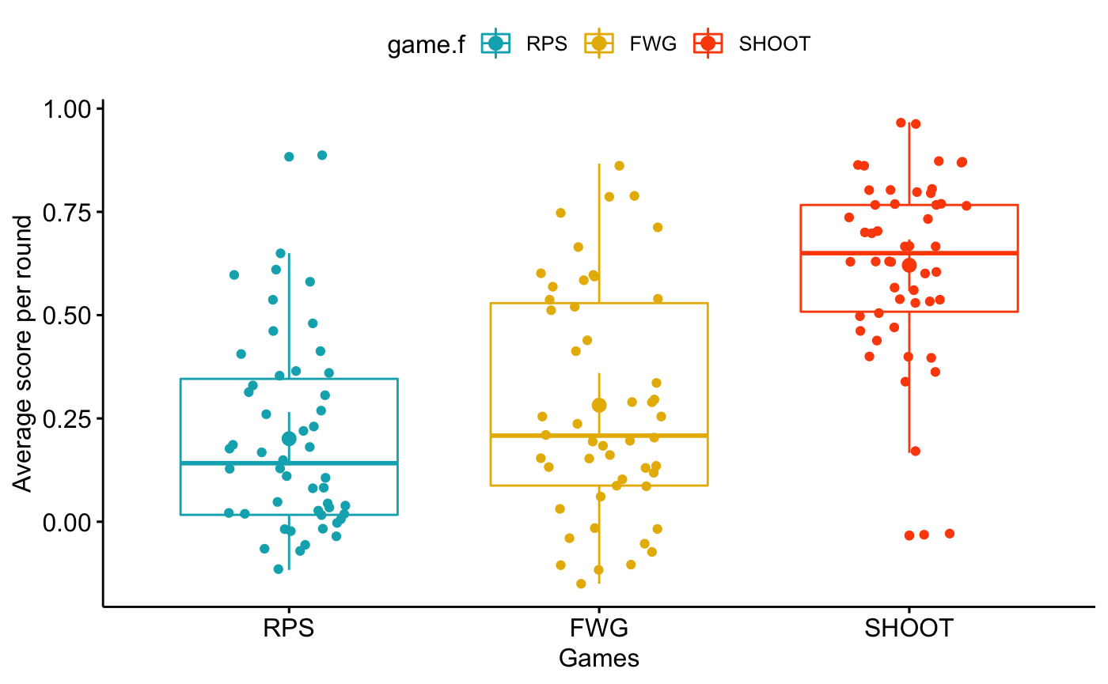

Figure 4: Distribution of unadjusted scores across games

Looking at scores for each game, the RPS game had the lowest average score (*M = 0.194, SD = 0.345*) followed by FWG (*M = 0.27, SD = 0.394*) and finally the Shootout game had the highest average score (*M = 0.622, SD = 0.326*). The higher score in shootout is expected as there are 2 out of three possible winning actions, compared to one out of three in RPS and FWG. Indeed, a player not aiming to uncover the opponent’s strategy and thus choosing to play randomly should be expected to have on average score of 0 in both RPS and FWG, and a score of 0.33 in the Shootout game.

Going forward, to make the scores more comparable, and because we are interested in player’s performance that is not due to chance, we will correct all scores by substituting the average score of a random strategy. As such, since RPS and FWG scores of a Nash strategy are 0, their score will be unchanged. However, all average scores per round in the shootout game will be subtracted by 0.33, the expected score of a random playing strategy, to disentangle skilled players from those who score merely due to chance.

Making these amendments, the average score per round for each game ar exhibited in figure 5. We see that there is an increasing performance as players go through games sequentially.

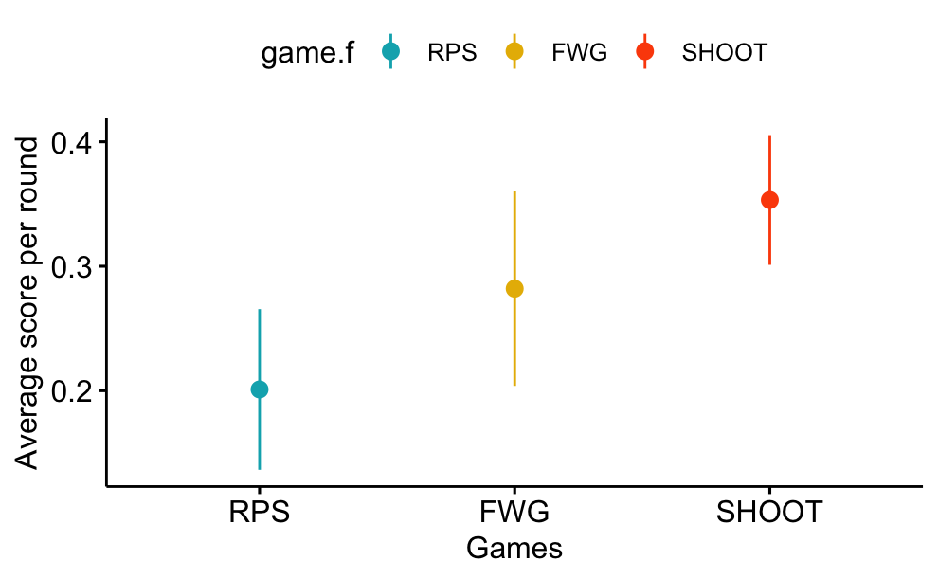

Figure 5: Average adjusted score per round for each game. Averaged across players.

To explore whether players were choosing actions randomly on average, we perform parametric one sample t-tests on average scores for each game, with the null hypothesis of a score consistent with random play. We use parametric t-tests as the sampling distribution of means should be normal according to the central limit theorem. The tests reject the hypothesis of random play in all three games (*RPS: t(49) = 6.26, p-value < 0.0001* ; *FWG: t(49) = 7.25* , *p-value < 0.0001 ; SHOOT: t(49) = 13.61, p-value < 0.0001 ).*

## Within and between-game learning

As reminder, there were three games (RPS, FWG and SHOOT) that were played on 4 stages each. In Stages 1 and 3, players faced a particular level-k opponent, while on stages 2 and 4 they faced the other level-k opponent (k = 1, 2). Also, the order in which they faced these players was different, as the study aimed to be counterbalanced for the order. Therefore 27 participants faced the level-1 opponent first, and 23 faced the level-2 opponent first. The variable “Condition” hereafter codes the levels of this factor.

To make the analysis easier, we will define two new factor variables: Interaction_lvl codes whether the stage of the game was the first or second interaction with the opponent in that game. Opp_type by contrast has two levels and tells us which opponent was faced in that block of play. For example, the last subgame in RPS will have Interaction_lvl of 2 as it was the second interaction with that opponent in RPS. The Opp_type will depend on the condition (which opponent was faced first). Therefore, it will be equal to level_2 if condition was level_1 and equal to Level_1 if condition was Level_2, since in the last stage the participant faced the opponent they did not face in the first stage

Using the average scores obtained by participants in each game and interaction, we explore whether learning has occurred within and between games. We perform a two (condition: level-1 first, level-2 first) by two ( opp_type: level_1 or level_2) by three (game: RPS, FWG, SHOOT) by two (interaction: first or second) repeated measures ANOVA with the first factor varying between participants. As the number of participants facing level-1 agents was slightly higher than those facing level-2 agents (27 vs 23), the ANOVA will not be balanced between the two levels of condition. We therefore used the “afex” (Singmann & al., 2016) package in R, as it allows us to handle unbalanced designs and produces type III sum of squares by default. The full results of this analysis are provided in Table 1.

|  |  |  |  |  |  |  |
| --- | --- | --- | --- | --- | --- | --- |
| Effect | Df1 | Df2 | MSE | F | ges | p-val |
| Condition | 1 | 48 | 0.43 | 0.45 | .003 | .51 |
| Game | 1.85 | 88.71 | 0.12 | 11.81*** | .04 | <.0001 |
| Condition * Game | 1.85 | 88.71 | 0.12 | 1.34 | .005 | .27 |
| Interaction_lvl | 1 | 48 | 0.06 | 1.34 | .001 | .25 |
| Condition*Interaction_lvl | 1 | 48 | 0.06 | 0.03 | <.0001 | .86 |
| Opp_type | 1 | 48 | 0.12 | 0.00 | <.0001 | .97 |
| Condition*Opp_type | 1 | 48 | 0.12 | 0.13 | .0002 | .72 |
| Game*Interaction_lvl | 1.99 | 95.72 | 0.08 | 0.46 | .001 | .64 |
| Condition*Game*Interaction_lvl | 1.99 | 95.72 | 0.08 | 2.43 + | .006 | .09 |
| Game*Opp_type | 1.70 | 81.82 | 0.11 | 5.31 ** | .01 | .010 |
| Condition*Game*Opp_type | 1.70 | 81.82 | 0.11 | 1.23 | .003 | .29 |
| Interaction_lvl*Opp_type | 1 | 48 | 0.04 | 2.16 | .001 | .15 |
| Condition*Interaction_lvl*Opp_ty | 1 | 48 | 0.04 | 0.02 | <.0001 | .88 |
| Game*Interaction_lvl*Opp_type | 1.89 | 90.83 | 0.09 | 0.96 | .002 | .38 |
| Condition*Game*Interaction_lvl* Opp_type | 1.89 | 90.83 | 0.09 | 0.94 | .002 | .39 |

Table 1: Repeated Measures ANOVA results

As we can see from the results above, there is evidence for a main effect of Game on scores (F*(1.85,88.7) = 11.81, ges = 0.04, p < .0001*), meaning that we reject the null hypothesis of scores in games being equal. To explore these differences further, we look at post-hoc analyses for pairwise comparisons between game scores (p-values adjusted using Holm method for multiple comparisons). We find the performance in the games increases steadily throughout the experiment, with FWG performance significantly higher than RPS (t*(96) =2.53, p = 0.025*), and performance in the SHOOT game also significantly higher than in FWG ( t*(96) =2.32, p = 0.025* ).

There was no main effect of either Opp_type, Interaction_lvl, or condition. This means that if we ignore potential secondary effects from interactions, neither the type of opponent faced, nor whether it was the first or second interaction with the opponent (see figure 7) nor which opponent was faced first did have a *main effect* on performance.

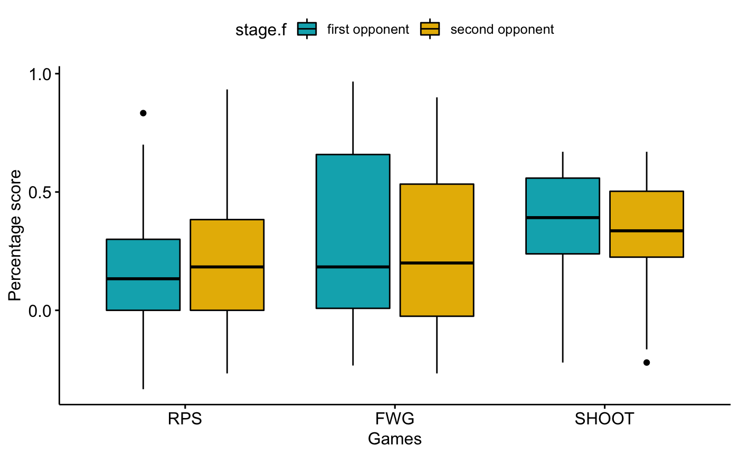

Figure 7: Average scores per interaction level across games played

However, one interaction did present a statistically significant effect: we find a significant two-way interaction effect between game and opponent type (F*(2,96) = 5.31, ges = 0.01, p = .01*). Below, we will look deeper into these interactions through more post-hoc tests involving pairwise comparisons.

## Within-Game learning

One way to measure within game learning is to compare the score on the first interaction with an opponent to the score on the second interaction with the same opponent within each game.

Figure 8 is an interaction plot displaying the score means by the within-subject factors: interaction level (whether that was first or second interaction with opponent) and game, for each of the two possible opponents (whether players faced a level-1 or level-2 opponent).

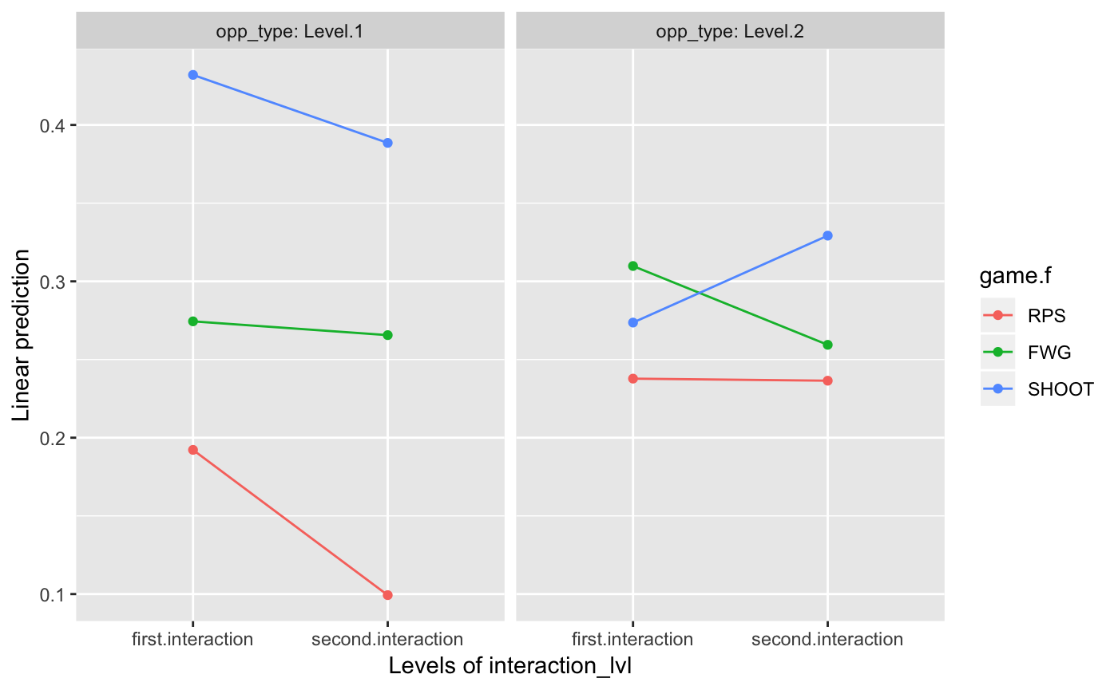

Figure 8: Marginal score means by Interaction level and Opponent type

Graphically, we see no meaningful upward trend indicative of within-game learning, where we would expect higher scores the second time a player interacts with an opponent, as opposed to the first time.

We test the differences between performance scores on the first and second interactions on each of the three games and for both opponent types separately and find no statistically significant differences in performance scores between first and second interaction with the opponent in all of the games. We therefore see no evidence of significant within-game learning when participants face both opponents sequentially as in this experimental paradigm.

## Transfer of learning between games

### Measuring transfer by comparing first interaction scores across games

The first way we use to measure learning transfer across games is through comparing the performance scores of players in the first interaction of each game by type of opponent faced, before within game learning might occur. Because the players always face the same opponent on the first stage for all games played, we can make this comparison irrespective of the condition. When we average across opponent types, the first interaction scores in the FWG game are not significantly higher than those in the first stage of the RPS game. Similarly, scores in the first stage of shootout are not significantly higher than the first stage of FWG. However, there is a significant increase in performance between the first interaction scores of RPS and SHOOT (*t(186) = 3.12, p = 0.01*).

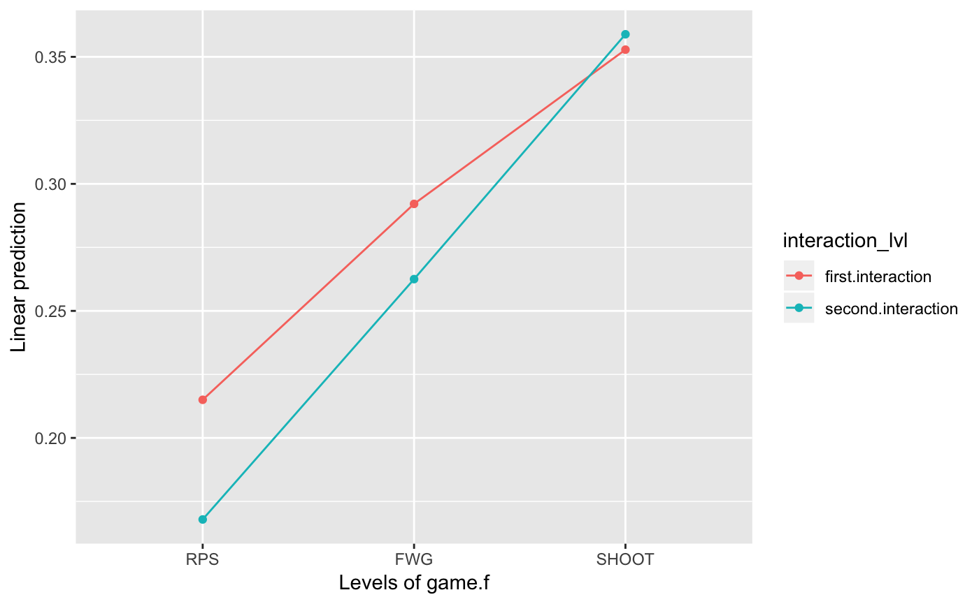

Figure 9: Marginal score means by game for first and second interaction by game

The above results indicate the presence of learning transfer across games when players face the first opponent, as participants do not start the games with a similar performance as when they first encountered RPS but show evidence of a higher propensity to win right away in the later games. It is intriguing why there is no evidence for transfer between the first interaction of RPS and FWG, and only on the third game (“Shoot”) is there evidence for transfer when looking at the first interaction scores. This might be due to the interaction of transfer with opponent type.

The above results were obtained by averaging across opponent types, which might muddle the conclusions. We now separate the two opponents faced to see whether the learning transfer is moderated by the type of opponent faced first. Because we are separating the cohort into two groups (those that faced level-1 opponent first and those that faced level-2 opponent first), we only need to focus on stage 1 performance scores. Figure 10 below shows the evolution of first interaction scores by game and type of opponent (red line).

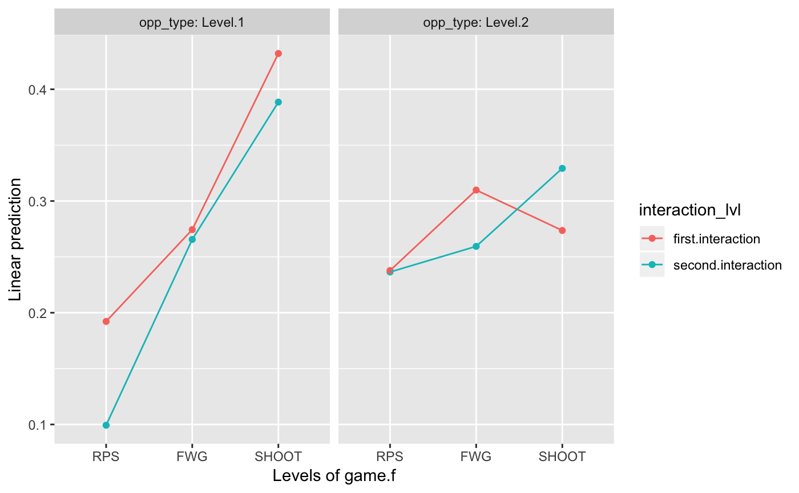

Figure 10: Marginal score means by game and opponent type for first and second interactions

Graphically, it seems the increase in first interaction scores is higher for participants facing level-1 opponents, compared to those facing level-2 opponents. Using t-tests, we find that the increase in performance between any two games first interactions is not statistically significant *for players facing the level-2 opponent*. However, for those facing level-1 opponents, there is a significant increase in scores between FWG and SHOOT *(t(376) = 2.58, p = 0.01)* as well as between RPS and SHOOT *(t(376) =3.92 , p = 0.001) .* For level-1 facing players, FWG first interaction scores were higher than those in RPS, but the increase in score was not statistically significant

Thus, focusing on scores from the first interaction, it appears that it was harder for participants to transfer knowledge about the opponent when facing level-2 opponents (which are strategically more sophisticated) than when facing level-1 opponents, and the weak increase in scores due to level-2 facing players was responsible for the lack of evidence for transfer when the two conditions were bundled together.

### Robustness check: Learning transfer using early round analysis

In the above analysis, we compared first interaction scores in each game, meaning the average score across the 20 rounds played in that stage for each game. The issue with averaging across the 20 rounds is that within game learning might occur in both source and goal task games, confounding our measure of learning transfer. If the player has the opportunity to learn about the opponent in the course of these 20 rounds, then our measure of learning transfer is not accurate as it includes potentially both within and across game learning.

Thus, as a robustness check, we will compare scores only on the first 5 rounds of each game (excluding the very first round where play is necessarily random). Because the number of rounds here is very limited, there should be very little learning within games, and we should be better measure learning transfer if it exits. In the figure below, we show the average score across participants in rounds 2-6. These scores are also averaged across the levels of condition (meaning they are irrespective of which opponent players faced first).

In figure 10, the average score across participants by game for rounds 2-6 are plotted. Scores are also averaged across levels of condition.

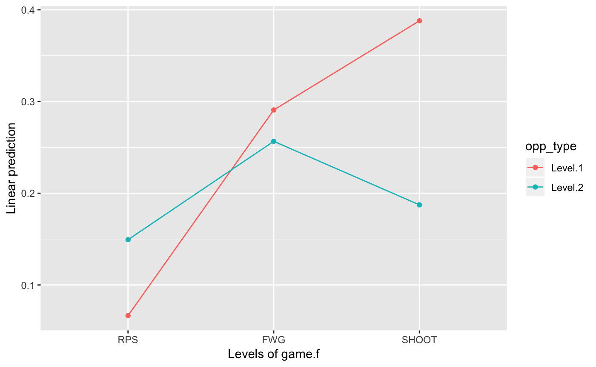

Figure 11: Marginal early round (2-6) score averages by game

We run hypothesis tests against the null hypothesis of 0 early scores in each game. As table 2 shows, unsurprisingly, the average early score in the first stage of the RPS game is not significantly different from 0 for level-1 opponent. More interestingly, early RPS scores for level-2 facing participants are significantly higher than 0 *(t(270) = 2.57, p = 0.0325).*

For both the FWG and SHOOT games, score in the early rounds of the first stage are significantly higher than 0 for both opponent types. *(Level-1 opponent: FWG: t(270) = 4.99, p < 0.0001; SHOOT: t(270) = 6.66, p < 0.0001; Level-2 opponent: FWG: t(270) = 4.40, p < 0.0001; SHOOT: t(270) = 3.21, p =0.004 ).*

|  |  |  |  |  |  |  |  |  |
| --- | --- | --- | --- | --- | --- | --- | --- | --- |
| Game | Opponent | Score 2-6 | SE | df | lower.CL | upper.CL | t-stat | p-value |
| RPS | Level.1 | 0.067 | 0.058 | 271 | -0.048 | 0.18 | 1.1 | 2.5e-01 |
| FWG | Level.1 | 0.291 | 0.058 | 271 | 0.176 | 0.41 | 5.0 | 1.1e-06*** |
| SHOOT | Level.1 | 0.388 | 0.058 | 271 | 0.273 | 0.50 | 6.7 | 1.5e-10*** |
| RPS | Level.2 | 0.149 | 0.058 | 271 | 0.035 | 0.26 | 2.6 | 1.1e-02** |
| FWG | Level.2 | 0.257 | 0.058 | 271 | 0.142 | 0.37 | 4.4 | 1.5e-05*** |
| SHOOT | Level.2 | 0.187 | 0.058 | 271 | 0.073 | 0.30 | 3.2 | 1.4e-03*** |

Table 2: Hypothesis tests of early round scores by game against null hypothesis of 0

In the above, our results confirm the existence of learning transfer when using early rounds analysis. It also confirms that it is easier to transfer learning to the more dissimilar game (Shoot) when facing a level 1 opponent. Indeed, while the early scores of FWG for level-1 and level-2 facing players are not significantly different from each other, the score of the players facing the level-1 opponent is indeed almost 0.2 point per round higher than that of players facing level-2 opponents, and the difference is statistically significant *( t(144) = 2.45 , p = 0.01).* These early scores have also been adjusted to account for the fact that the shootout game has higher average scores when playing randomly, and therefore this difference is really due to better learning transfer than chance.

## Computational Modelling of observed behaviour

We saw from the above that players are adapting to the opponent strategy, learning to win at a higher rate the more the game goes on. In order to determine whether players engage in strategies that mimic the level-k reasoning approach of the opponent, we compare the observed behaviour to predictions from multiple potential models of play. In total, we contrast observed behaviour with five models. The first approach is random play consistent with a Nash equilibrium player, in which participants choose their actions randomly. The second to fourth approach are level-k strategies, with k varying from 1 to 3. Finally, we added a fifth model based on a simple heuristic that has proven effective in modelling behaviour in other games (Steyvers et al. 2009; Worthy & Maddox, 2012): The win-stay lose-shift rule posits that players will repeat actions that won in the round immediately prior, and change actions if the previous one lost. Ties are treated as wins in this case, as otherwise, given our particular games choice, if we treat ties as losses then we get back the same predictions as a level-1 model.

In modelling the players behaviour, we also make the assumption that none of the strategies above is followed consistently. Instead, we assume that players choose the strategies with probability $θ$, and choose equally amongst the other models with probability 1- $θ$. We estimate this parameter $θ$ for each player and each potential model using Maximum Likelihood estimation: Finding the parameter $θ$ that would maximise the probability of the actual actions being observed. Since we also see that players learn through the games, we run a second computational model in which the parameter $θ$ is allowed to vary between games. As a model selection criterion, we choose the BIC to compare the fit of the various models to observed behaviour. We fit the models to two separate datasets of play, one that includes stages 1 and 3 only for each game, in which players faced a specific type of opponent, and the other includes stages 2 and 4, in which players faced the other opponent.

The results of fitting the various models to data from stages 1 and 3 is presented in table 3 below.

|  |  |  |  |  |
| --- | --- | --- | --- | --- |
| Opponent | Level-1 | Level-2 | Level-3 | Random |
| Level-1 | 5 | 6 | 11 | 5 |
| Level-2 | 0 | 2 | 9 | 12 |

Table 3: Distribution of best fitting player model by type of opponent in stages 1 &3

We see that while there is heterogeneity in the strategies people play, a significant number of players choose actions that are best responses to their opponent’s play, by adopting a level k+1 strategy when facing a level-k player. While there is also a large number of players that never learned the opponent’s strategy and continue to play randomly, a group of 15 out of the 50 participants did indeed choose the strategy with the best response.

The high number of random strategy players stems from the inclusion of the shootout game in the mix, since many level-k strategies allow multiple predictions, random choice ends up doing well in model fitting in shootout, as such biasing the categorisations towards random strategy players.

These results are confirmed when looking at data only from stages 2 and 4 where players faced the other opponent and in which a significant number of layers best responded to the computer opponent’s strategy.

|  |  |  |  |  |
| --- | --- | --- | --- | --- |
| Opponent | Level-1 | Level-2 | Level-3 | Random |
| Level-1 | 4 | 5 | 5 | 9 |
| Level-2 | 0 | 1 | 16 | 10 |

Table 4: Best fitting player model for stages 2&4

Again, we have a high number of random players as well as similar numbers of level-k players for the level-1 opponent, not showing clearly that the majority of players were using level-2 strategies. This is also due to the fact that the shootout game is not very well designed to uncover high levels of strategic reasoning, since multiple actions can be consistent with level-k strategies, for a particular k. For instance, if the last human action was to shoot left and the opponent dived right, then a level-1 player can choose two actions to beat a level-0 opponent: shooting center or right. Likewise, a level-3 player would have the possibility of choosing the two same actions. Also, one of the particularities of this game is that level-1 and level-3 strategies predictions are identical, meaning that the likelihoods will be the same for both strategies.

# Discussion

The online experiment we undertook meant to explore within and across game learning in strategic interaction using three simple zero sum games where human participants played against 2 computer opponents with strategies consistent with level-k reasoning.

The first finding is that human participants learn the opponent’s strategy over time and exploit that knowledge. They do not necessarily engage in random play throughout the experiment, even though for all three games played, the game theoretic efficient strategy (Nash Equilibrium) dictates a random choice over actions. This in itself confirm findings from behavioural game theory literature that human players deviate from the Nash equilibrium (Camerer, 2003). While this may seem obvious, it is noteworthy that some participants decide to search for a way to exploit the opponent, since the games played are perhaps some of the best examples we have of random ways of making choices, settling disputes between people (RPS) or designating a winner when other more usual methods fail (SHOOT).

Further, when making participants face two opponents sequentially, we found no evidence for within game learning, as scores during the second interaction with the opponent for each game were not significantly different from those during the first interaction. This is a little puzzling since we would expect more exposure to an opponent to lead to higher performance scores. This is in contrast to findings from the literature showing that people learn to adapt to the opponent with exposure (De Bruine, 2002; Hancock & DeBruine, 2003). We believe the failure to exhibit within game learning in this experiment could be explained by two potential reasons. First, it might be related to the limit number of rounds players have against each opponent, and the higher cognitive load linked to facing multiple opponents, where players need to keep in mind each opponent’s characteristics. When similar experiments were ran by the researcher, in which players only faced one type of opponent, and played repeatedly 50 rounds of each game, we uncovered evidence of within-game learning. The setting and initial two games were similar, and as such we link the absence of within game learning to the change in experimental procedure. After all, facing an opponent for 20 rounds and then having to face a different opponent is a much more limited exposure than playing against the same opponent for 50 rounds. We believe that by the time players were understanding how to beat the opponent in each stage, the stage was over, and they had to play a different opponent, as such impeding within game learning. This is not inconsistent with any evidence of later learning and transfer, since players would have faced each opponent a total of 30 rounds by the end of each game, on two different interlaced occasions, so learning may happen by then. The other reason we put forward is that comparing first and second interaction scores might not be the best way to measure within game learning, since players might learn throughout the first interaction, having better scores by the end of it, then because they face a completely different opponent afterwards, they might need to unlearn the new opponent’s strategy before the second interaction, leading to low scores during most of the second interaction as well. A better way to measure within-game learning in the future might be to compare early and late interaction rounds (for instance first and last 5 rounds in a sub-game).

Having said that, we believe our experimental paradigm was better suited to explore our main research question, related to learning transfer rather than within-game learning. Indeed, when facing two opponents sequentially, there are many more opportunities to test transfer than before. Indeed, there are 2 opportunities to transfer knowledge within each game, and a total of three games, which means 6 opportunities to test transfer. Had we focused on making players face only one type of opponent each, we would only have two possible learning transfers.

In that regard, the results on learning transfer were interesting. While there was no evidence of learning transfer across interactions within the same game (likely due to the same factors we discuss above), we found evidence for learning transfer across games as both first stage and early round analysis confirm statistically significant increases in performance from RPS to FWG and SHOOT.

We also found that learning transfer is modulated by the type of opponent faced. When the players faced the level-1 opponent, they were able to transfer learning. However, when they faced the level-2 opponent, there was weaker evidence for transfer. The lack of transfer when facing the more sophisticated opponent might be due to the difficulty of learning that opponent strategy to start with. A player cannot transfer what they have not learnt and as such, since it might be harder to learn the strategy of the level-2 opponent, this in turn might translate into weaker evidence for transfer.

Coming back to evidence for learning transfer, it is undeniable that participants start off new games with prior knowledge as their scores are much higher than chance, confirmed both by early stage analysis as well as rounds 2-6 scores analysis. The question we ask ourselves therefore is: What exactly did the players learn in RPS that allowed them to beat the opponent in FWG and SHOOT? And what form did this learning take?

Since the experiment was specifically designed to impede any sort of spatial heuristics by randomly shuffling the actions display after each round, there was no possible easy spatial heuristics that participants could learn. If we had not shuffled the order of display of the actions, participants could uncover patterns that happen to work against these level-k players because of the cyclicality between action choices. This was no longer possible in this experiment.

Another possible explanation is that participants learn a mapping between specific past choices and round outcome. For instance, a player may be thinking: “Playing rock after I have played paper in the last round has a higher probability of winning”. These past to current round choice mappings are easy to learn and retrieve, and in some circumstances, might be effective against our opponents (during a winning streak, it is possible to learn a sequence that wins every time if the computer opponent doesn’t choose actions stochastically in the 10% of rounds we allow). This is an example of associative learning that is easy to acquire as humans would only need to memorise three “transitions” and would be akin to a reinforcement-learning type of behaviour *(Erev & Roth, 1998*) in which players tend to choose plays that yielded positive rewards in the past.

Having said that, this explanation is at odds with transfer in early rounds. After all, the later games have different actions than earlier games, and even in the similar FWG game, where the game is almost identical, the actions don’t have the same labels. As such, transferring the learned mapping to the new game is not possible and this explanation cannot account for learning transfer seen in the first 5 rounds.

Other possible explanations such as memorising the structure of the state-action space and learning the optimal action in each state, which is akin to a model-based reinforcement learning approach, is also not sufficient to explain the presence of learning transfer (Sutton & Barto, 1998), especially that adapting to the new environment in later games cannot be achieved within a very limited number of rounds.

To explain the presence of learning transfer, we believe that the most probable account is that some participants are learning a “strategic rule” by which they can anticipate the opponent’s next action and best respond to it. Certainly, given the heterogeneity in game scores, not all participants were able to do that. As we can see from figure 13, some players are able to score consistently high in early stages and keep a good performance throughout the game while other never quite manage to consistently beat the opponent.

Given the evidence for transfer in early rounds, we believe a significant number of participants did indeed uncover patterns in the opponent’s play that they could leverage to anticipate future actions. In fact, the correlation coefficient between scores against level-1 and level-2 opponents is 57%, significantly higher than 0.

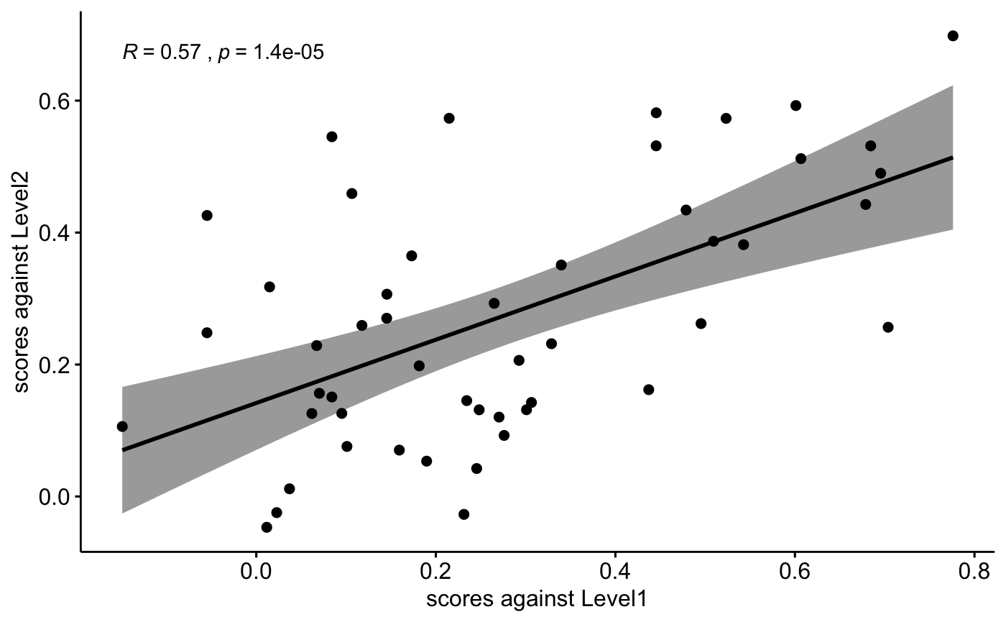

Figure 12: Scatterplot of players scores against level-1 vs level-2 opponents

This learning can take many forms, of which we can distinguish at least two. First, the cyclicality of the dominance between the 3 choices available in each game is such that some very simple heuristics can be very effective against both opponents. For instance, against a level 2 opponent, a simple heuristic that circumvents the level-k mental representation, and consistently chooses the opponent’s last round choice can beat the level-2 opponent in every round (or almost every round since the opponent still plays randomly 10% of the time…). This heuristic can be used in all 3 games and could potentially account for transfer in early rounds of the latter games when facing the level-2 player. This heuristic does not work for level-1 opponent though.

The other possibility is that participants successfully build an explicit representation of what the opponent is actually doing. For instance, against a level-1 player, some participants may correctly express the opponent’s strategy as: *“This computer opponent always seems to think I will be repeating my choice from the previous round”.* Humans can naturally leverage their theory of mind abilities to reason about the motives of the opponent and build such mental representations, and this would be akin to the more general framework or rule-based learning explored by Stahl (2000, 2003).

More importantly, this type of rule-based learning is also robust to small descriptive changes in the game environment, such as changing the labels of the actions (which is effectively what FWG is to RPS) and to dissimilar games (such as SHOOT). Indeed, one could apply the rule we articulated against the level-1 opponent equally successfully in all three games. If the player has uncovered such a representation of the opponent, then it would be easy to apply it to early rounds of the later games, and it would indeed account for the learning transfer we saw.

To explore evidence for each possible rule (heuristics vs mental representation of level-k opponent’s strategy), we need to look at the differential performance between human participants facing level-1 and level-2 opponents. Indeed, the heuristic we mentioned above only works against level-2 opponents, and as far as we can tell, there was no simple heuristic that worked consistently against level-1 opponents. By contrast, the mental representation is harder to learn when facing level-2 opponents, as it requires at least 3 levels of thinking (I believe that my opponent thinks that I think they will repeat their last round choice) vs only two levels of thinking when facing level-1 opponent ( I believe that my opponent thinks I will repeat my last choice). If indeed participants were using heuristics, then their performance against the level-2 player should be high, as well as evidence for transfer between both similar and dissimilar games. Since there are no easy heuristics against level-1 player, we should not see evidence for transfer when playing level-1 if people are indeed using these. If on the contrary they were building a mental representation of the opponent’s strategy, then we should see evidence of learning and transfer against both opponents, but especially against level-1 opponents.

To answer the question, we refer to figure 10 in the results section, and we focus on the red line which represents scores on the first stage of each game, by condition. Thus, the red line on the left chart represents performance against level-1 computer opponents across first stage of games, while the red line on the right chart represents the same performance for those facing level-2 computer opponents. As we outlined in the result section, there is indeed evidence for transfer in both situations, with high differential scores for those facing level-1 opponents. This is exactly consistent with the predictions of an explicit, level-k, mental representation of the opponent’s strategy rather than the use of a simple “play opponent’s last choice” heuristic. Therefore, we conclude that the most viable explanation is the use by some players of an explicit model of the opponent rather than rely on heuristics to learn the strategy of the computer agents and transfer this knowledge to new situations.

## Future Developments:

# While the outcome of the online experiment confirmed most of our hypotheses, we believe there is still ample room for improvement in both the experimental design and computational modelling in order to explore the question of opponent modelling as a means of transfer in human players.

In terms of experimental design, the choice of the shootout game was not optimal in hindsight, as it didn’t allow the certain identification of the type of level-k player from observing actions. Indeed, because two actions can beat the opponent’s last choice, a level-1 cannot be identified by simply looking at the action chosen since two of them would be consistent with his strategy. The same would apply for a level-3 player. This also creates problems in computational modelling of player strategies. The challenge for future research is to choose games that are both engaging, not too dissimilar amongst themselves and allowing easy identification of level-k strategies. Some famous games that allow easy identification of level-k strategies such as p-beauty contests (Camerer, 2003) and the lemonade stand game (Zinkevich et al., 2011) were deemed not engaging enough for participants playing hundreds of rounds.

In terms of computational modelling, other strategies could be tested as well, such as those relying on simple heuristics, models involving short term memory or pattern recognition, and model-based reinforcement learning strategies.

Finally, a rich source of additional insights is the study of response time and written feedback from the participants, and how they correlate to performance in these tasks and the ability to transfer learning. Since having a proper mental representation of the opponent’s level-k reasoning is arduous, very short response times indicate players not engaging properly with the study, or having learned simple heuristics to beat the opponent, whereas long response times indicate players that are at least trying to understand the opponent’s play, and at best players engaged in representing the level-k strategy and how to best respond to it. Self-reports can also help shed some light on whether the participants are able to articulate the strategy of the opponent, and along computational modelling, can indeed help categorise participants into those who did manage to learn and articulate a model of the opponent, and those who didn’t.

# Conclusion

Our online experiments confirm behavioural game theory results, stating that human players can deviate from Nash equilibrium play and learn to adapt to the opponent strategy and exploit it when the opponent itself is deviating from Nash equilibrium. Moreover, we showed that participants do transfer their learning to new games with varying degrees of similarity. The most likely explanation as we saw is that players build a mental representation of their opponent strategy, rather than rely on associative learning or action-based heuristics. The transfer is also moderated by the level of sophistication of the opponent, with participants showing more success in learning and transferring against opponents adopting a less sophisticated strategy.

Having said that, there remains a high degree of heterogeneity between players. There is a high positive association between players who learn to beat the sophisticated and less sophisticated opponents, indicating that some players are more able to detect the patterns in opponent play and learn how to exploit them. Moreover, the computational modelling shows that a significant number of players are still using random strategies in the games. Whether this ability depends on engagement with the experiment or on other characteristics of the learner is an open question that more research in the area would hope to answer.

**Bibliography**

Anzai, Y., & Simon, H. A. (1979). The theory of learning by doing. *Psychological review*, *86*(2), 124.

Agranov, M., Potamites, E., Schotter, A., & Tergiman, C. (2012). Beliefs and endogenous cognitive levels: An experimental study. *Games and Economic Behavior*, *75*(2), 449-463.

Arad, A., & Rubinstein, A. (2012). The 11-20 money request game: A level-k reasoning study. *American Economic Review*, *102*(7), 3561-73.

Asadi, M., & Huber, M. (2007, January). Effective Control Knowledge Transfer through Learning Skill and Representation Hierarchies. In *IJCAI* (Vol. 7, pp. 2054-2059).

Aumann, R. (1959). Acceptable points in general cooperative n-person games. *Contributions to the Theory of Games (AM-40)*, *4*, 287-324.

Bicchieri, C. (1988). Strategic behavior and counterfactuals. *Synthese*, *76*(1), 135-169.

Binmore, K. (1987). Modeling Rational Players: Part I: Ken Binmore.

Brown, G. W. (1951). Iterative solution of games by fictitious play. *Activity analysis of production and allocation*, *13*(1), 374-376.

Brown, J. N., & Rosenthal, R. W. (1990). Testing the minimax hypothesis: a re-examination of O'Neill's game experiment. *Econometrica: Journal of the Econometric Society*, 1065-1081.

Camerer, C. F., & Knez, M. (2000). Increasing cooperation in prisoner's dilemmas by establishing a precedent of efficiency in coordination.

Camerer, C., & Hua Ho, T. (1999). Experience‐weighted attraction learning in normal form games. *Econometrica*, *67*(4), 827-874.

Camerer, C. F., Ho, T. H., & Chong, J. K. (2002). Functional EWA: a one-parameter theory of learning in games.

Camerer, C., Ho, T., & Chong, K. (2003). Models of thinking, learning, and teaching in games. *American Economic Review*, *93*(2), 192-195.

Camerer, C. F., Ho, T. H., & Chong, J. K. (2004). A cognitive hierarchy model of games. *The Quarterly Journal of Economics*, *119*(3), 861-898.

Camerer, C. F. (2011). *Behavioral game theory: Experiments in strategic interaction*. Princeton University Press.

Cheung, Y. W., & Friedman, D. (1997). Individual learning in normal form games: Some laboratory results. *Games and Economic Behavior*, *19*(1), 46-76.

Coricelli, G. (2005). Strategic interaction in iterated zero-sum games. *Homo Oeconomicus, forthcoming*, *835*.

Costa-Gomes, M., and Crawford, V. P. “Cognition and Behavior in Two-person Guessing games: An Experimental Study.” American Economic Review 96, no. 5 (2006): 1737–1768.

Costa-Gomes, M., Crawford, V. P., and Broseta, B. “Cognition and Behavior in Normal- form Games: An Experimental Study.” Econometrica 69, no. 5 (2001): 1193–1235.

Crawford, V. P., Costa-Gomes, M. A., and Iriberri, N. “Structural Models of Nonequi- librium Strategic Thinking: Theory, Evidence, and Applications.” Journal of Economic Liter- ature 51, no. 1 (2013): 5–62.

Crawford, V. P., and Iriberri, N. “Level-k Auctions: Can a Nonequilibrium Model of Strategic Thinking Explain the Winner’s Curse and Overbidding in Private-Value Auctions?” Econometrica 75, no. 6 (2007): 1721–1770.

Croonenborghs, T., Driessens, K., & Bruynooghe, M. (2007, June). Learning relational options for inductive transfer in relational reinforcement learning. In *International Conference on Inductive Logic Programming* (pp. 88-97). Springer, Berlin, Heidelberg.

Daskalakis, C., Goldberg, P. W., & Papadimitriou, C. H. (2009). The complexity of computing a Nash equilibrium. *SIAM Journal on Computing*, *39*(1), 195-259.

Doucouliagos, C. (1994). A note on the evolution of homo economicus. *Journal of Economic Issues*, *28*(3), 877-883.

Eisenhardt, K. M. (1989). Agency theory: An assessment and review. *Academy of management review*, *14*(1), 57-74.

Erev, I., & Roth, A. E. (1998). Predicting how people play games: Reinforcement learning in experimental games with unique, mixed strategy equilibria. *American economic review*, 848-881.

Fernández, F., & Veloso, M. (2006, May). Probabilistic policy reuse in a reinforcement learning agent. In *Proceedings of the fifth international joint conference on Autonomous agents and multiagent systems* (pp. 720-727). ACM.

Foerster, J., Chen, R. Y., Al-Shedivat, M., Whiteson, S., Abbeel, P., & Mordatch, I. (2018, July). Learning with opponent-learning awareness. In *Proceedings of the 17th International Conference on Autonomous Agents and MultiAgent Systems* (pp. 122-130). International Foundation for Autonomous Agents and Multiagent Systems.

Frey, S., & Goldstone, R. L. (2013). Cyclic game dynamics driven by iterated reasoning. *PloS one*, *8*(2), e56416.

Georganas, S., Healy, P. J., and Weber, R. A. “On the Persistence of Strategic Sophis- tication.” Journal of Economic Theory 159 (2015): 369–400.

Goldman, A. I. (1992). In defense of the simulation theory. *Mind & language*, *7*(1‐2), 104-119.

Haruvy, E., & Stahl, D. O. (2012). Between-game rule learning in dissimilar symmetric normal-form games. *Games and Economic Behavior*, *74*(1), 208-221.

He, H., Boyd-Graber, J., Kwok, K., & Daumé III, H. (2016, June). Opponent modeling in deep reinforcement learning. In *International Conference on Machine Learning* (pp. 1804-1813).

Ho, T. H., Camerer, C., & Weigelt, K. (1998). Iterated dominance and iterated best response in experimental" p-beauty contests". *The American Economic Review*, *88*(4), 947-969.

Hoffman, M., Suetens, S., Gneezy, U., & Nowak, M. A. (2015). An experimental investigation of evolutionary dynamics in the Rock-Paper-Scissors game. *Scientific reports*, *5*, 8817.

Hong, Z. W., Su, S. Y., Shann, T. Y., Chang, Y. H., & Lee, C. Y. (2018, July). A deep policy inference q-network for multi-agent systems. In *Proceedings of the 17th International Conference on Autonomous Agents and MultiAgent Systems* (pp. 1388-1396). International Foundation for Autonomous Agents and Multiagent Systems.

Holyoak, K. J., & Spellman, B. A. (1993). Thinking. *Annual review of psychology*, *44*(1), 265-315.

J.B. Van Huyck, R.C. Battalio, and F.W. Rankin. On the origin of convention: Evidence from coordination games. The Economic Journal, 107(442):576-596, 1997.

Juvina, I., Saleem, M., Martin, J. M., Gonzalez, C., & Lebiere, C. (2013). Reciprocal trust mediates deep transfer of learning between games of strategic interaction. *Organizational Behavior and Human Decision Processes*, *120*(2), 206-215.

Kuvayev, D., & Sutton, R. S. (1997). *Model-based reinforcement learning*. Tech. rept. university of massachusetts, Dept of computer science.

Lenth, R. V., & Hervé, M. (2015). lsmeans: Least-squares means. *R package version*, *2*, 20-3.

Li, S., Wu, Y., Cui, X., Dong, H., Fang, F., & Russell, S. (2019). Robust multi-agent reinforcement learning via minimax deep deterministic policy gradient. In *AAAI Conference on Artificial Intelligence (AAAI)*.

Lurie, N. H., & Swaminathan, J. M. (2009). Is timely information always better? The effect of feedback frequency on decision making. *Organizational Behavior and Human decisión processes*, *108*(2), 315-329.

Madden, M. G., & Howley, T. (2004). Transfer of experience between reinforcement learning environments with progressive difficulty. *Artificial Intelligence Review*, *21*(3-4), 375-398.

Mengel, F., & Sciubba, E. (2014). Extrapolation and structural similarity in games. *Economics Letters*, *125*(3), 381-385.

Messick, D. M. (1967). Interdependent decision strategies in zero‐sum games: A computer‐controlled study. *Behavioral Science*, *12*(1), 33-48.

Mookherjee, D., & Sopher, B. (1994). Learning behavior in an experimental matching pennies game. *Games and Economic Behavior*, *7*(1), 62-91.

Morgenstern, O., & Von Neumann, J. (1953). *Theory of games and economic behavior*. Princeton university press.

Nash, J. F. (1950). Equilibrium points in n-person games. *Proceedings of the national academy of sciences*, *36*(1), 48-49.

Nash, J. (1951). Non-cooperative games. *Annals of mathematics*, 286-295.

Nagel, R. (1995). Unraveling in guessing games: An experimental study. *The American Economic Review*, *85*(5), 1313-1326.

Nguyen, T., Nguyen, N. D., & Nahavandi, S. (2018). Multi-agent deep reinforcement learning with human strategies. *arXiv preprint arXiv:1806.04562*.

Osborne, M. J., & Rubinstein, A. (1994). *A course in game theory*. MIT press.

Östling, R., Wang, J. T. Y., Chou, E. Y., & Camerer, C. F. (2011). Testing game theory in the field: Swedish LUPI lottery games. *American Economic Journal: Microeconomics*, *3*(3), 1-33.

Pan, S. J., & Yang, Q. (2009). A survey on transfer learning. *IEEE Transactions on knowledge and data engineering*, *22*(10), 1345-1359.

Peltomäki, M., & Alava, M. (2008). Three-and four-state rock-paper-scissors games with diffusion. *Physical Review E*, *78*(3), 031906.

Premack, D., & Woodruff, G. (1978). Does the chimpanzee have a theory of mind?. *Behavioral and brain sciences*, *1*(4), 515-526.

Price, B., & Boutilier, C. (1999, June). Implicit imitation in multiagent reinforcement learning. In *ICML* (pp. 325-334).

Rabinowitz, N. C., Perbet, F., Song, H. F., Zhang, C., Eslami, S. M., & Botvinick, M. (2018). Machine theory of mind. *arXiv preprint arXiv:1802.07740*.

Raileanu, R., Denton, E., Szlam, A., & Fergus, R. (2018). Modeling others using oneself in multi-agent reinforcement learning. *arXiv preprint arXiv:1802.09640*.

Rankin, F. W., Van Huyck, J. B., & Battalio, R. C. (2000). Strategic similarity and emergent conventions: Evidence from similar stag hunt games. *Games and Economic Behavior*, *32*(2), 315-337.

Reichenbach, T., Mobilia, M., & Frey, E. (2007). Mobility promotes and jeopardizes biodiversity in rock–paper–scissors games. Nature, 448(7157), 1046.

Rick, S., & Weber, R. A. (2010). Meaningful learning and transfer of learning in games played repeatedly without feedback. *Games and Economic Behavior*, *68*(2), 716-730.

Rosenthal, R. W., Shachat, J., & Walker, M. (2003). Hide and seek in Arizona. *International Journal of Game Theory*, *32*(2), 273-293.

Salmoni, A. W., Schmidt, R. A., & Walter, C. B. (1984). Knowledge of results and motor learning: a review and critical reappraisal. *Psychological bulletin*, *95*(3), 355.

Shachat, J., & Swarthout, J. T. (2004). Do we detect and exploit mixed strategy play by opponents? *Mathematical Methods of Operations Research*, *59*(3), 359-373.

Sharma, M., Holmes, M. P., Santamaría, J. C., Irani, A., Isbell Jr, C. L., & Ram, A. (2007, January). Transfer Learning in Real-Time Strategy Games Using Hybrid CBR/RL. In *IJCAI*(Vol. 7, pp. 1041-1046).

Simon, H. A. (1972). Theories of bounded rationality. *Decision and organization*, *1*(1), 161-176.

Singh, S. P. (1992). Transfer of learning by composing solutions of elemental sequential tasks. *Machine Learning*, *8*(3-4), 323-339.

Singmann, H., Bolker, B., Westfall, J., Aust, F., Højsgaard, S., Fox, J., ... & Love, J. (2016). afex: analysis of factorial experiments. R package version 0.16-1.

Sonsino, D., & Sirota, J. (2003). Strategic pattern recognition—experimental evidence. *Games and Economic Behavior*, *44*(2), 390-411.

Spiliopoulos, L. (2013). Beyond fictitious play beliefs: Incorporating pattern recognition and similarity matching. *Games and Economic Behavior*, *81*, 69-85.

Stahl, D. O., & Wilson, P. W. (1995). On players′ models of other players: Theory and experimental evidence. *Games and Economic Behavior*, *10*(1), 218-254.

Stahl, D. O. (2000). Rule learning in symmetric normal-form games: theory and evidence. *Games and Economic Behavior*, *32*(1), 105-138.

Steyvers, M., Lee, M. D., & Wagenmakers, E. J. (2009). A Bayesian analysis of human decision-making on bandit problems. *Journal of Mathematical Psychology*, *53*(3), 168-179.

Sutton, R. S., & Barto, A. G. (1998). *Introduction to reinforcement learning* (Vol. 135). Cambridge: MIT press.

Tanaka, F., & Yamamura, M. (2003, July). Multitask reinforcement learning on the distribution of MDPs. In *Proceedings 2003 IEEE International Symposium on Computational Intelligence in Robotics and Automation. Computational Intelligence in Robotics and Automation for the New Millennium (Cat. No. 03EX694)* (Vol. 3, pp. 1108-1113). IEEE.

Taylor, M. E., Stone, P., & Liu, Y. (2005, July). Value functions for RL-based behavior transfer: A comparative study. In *AAAI*(Vol. 5, pp. 880-885).

Taylor, M. E., Kuhlmann, G., & Stone, P. (2008). Transfer Learning and Intelligence: an Argument and Approach. *Frontiers in artificial intelligence and applications*, *171*, 326.

Torrey, L., & Shavlik, J. (2010). Transfer learning. In *Handbook of research on machine learning applications and trends: algorithms, methods, and techniques* (pp. 242-264). IGI Global.

Weber, R. A. (2003). Learning and transfer of learning with no feedback: An experimental test across games.

Weber, R. A., & Rick, S. (2008). *Meaningful learning and transfer of learning in games played repeatedly without feedback*. working paper.

Wimmer, H., & Perner, J. (1983). Beliefs about beliefs: Representation and constraining function of wrong beliefs in young children's understanding of deception. *Cognition*, *13*(1), 103-128.

Worthy, D. A., Otto, A. R., & Maddox, W. T. (2012). Working-memory load and temporal myopia in dynamic decision making. *Journal of Experimental Psychology: Learning, Memory, and Cognition*, *38*(6), 1640.

Zawadzki, E. (2005) Multiagent learning and empirical methods*. Master’s thesis, University of British Columbia.*

Zinkevich, M. A., Bowling, M., & Wunder, M. (2011). The lemonade stand game competition: solving unsolvable games. *ACM SIGecom Exchanges*, *10*(1), 35-38.